

***Strangeraise***

*——an entrepreneurial platform for undergraduates*

**Project detailed document**

**组员信息**

**目录**

**1 Business Analysis** 5

**1.1 Background** 5

**1.2 Question Analysis** 6

**1.3 Conclusion：Strangeraise platform** 7

**1.4 Market Analysis** 7

**1.4.1 Related platform comparison** 7

**1.4.2 Stakeholder Questionnaire** 11

**1.4.2 调查数据分析** 16

**1.5 The Scope of Business** 21

**1.6 The Vision** 23

**1.7 Feasibility** **Analysis** 24

**1.7.1 Stakeholder** **Analysis** 24

**1.7.2 SWOT Analysis** 25

**1.7.3 The Schedule of Value Return** 28

**1.8 Solution** 29

**1.8.1 Proposed solution** 29

**1.8.2 Deep analysis for solutions** 34

**1.8.3 ROI analysis of the solution** 38

**2 project startup** 41

**2.1 System development methods and key steps** 41

**2.2 Scope model** 42

**2.2.1 Context model** 42

**2.2.2 Conceptual model** 42

**2.2.3 Problem-object model** 43

**2.3 Business Use Case** 43

**2.3.1 Use case model** 43

**2.3.2 Statement of personal use case** 44

**2.4 Procedural model** 49

**2.4.1 Function decomposition diagram** 49

**2.4.2 Procedural model** 51

**2.5 Definition of rules** 52

**2.6 业务风险** 52

**3 Demands analysis and explaination** 55

**3.1 Functional demans** 55

**3.1.1 System Use Case Model** 55

**3.1.2 Descriptions of System Use Case** 55

**3.2 非功能性需求** 74

**3.2.1 用户界面需求** 74

**3.2.2 产品质量需求** 74

**4 概要设计** 77

**4.1 总体设计** 77

**4.2 部署架构** 77

**4.3 功能模块结构** 78

**4.3.1 个人管理模块** 79

**4.3.2 项目管理模块** 80

**4.3.3 日志** 80

**4.3.4 推荐** 82

**4.3.5 成员管理模块** 83

**4.4 关键技术介绍** 85

**5 详细设计** 85

**5.1 包设设计** 85

**5.2 模块设计** 85

**5.2.1 个人模块设计** 85

**5.2.2 项目模块设计** 85

**5.2.3 成员模块设计** 86

**5.2.4 推荐模块设计** 86

**5.2.5 日志模块设计** 86

**5.3 关键类说明** 87

**5.3.1 sfsfsdfsdf** 87

**6 数据建模** 88

**6.1 概念模型** 88

**6.2 逻辑模型** 88

**6.3 物理模型** 88

**6.4 sdsdsd** 88

**7 架构设计** 89

**7.1 架构风格** 89

**7.2 设计模式的应用与实现** 90

**7.2.1 状态模式** 90

**7.2.2 工厂模式和单例模式结合模式** 90

**7.2.3 策略模式** 91

**7.2.4 组合模式** 91

**7.2.5 观察者模式** 92

**7.2.6 备忘录模式** 92

**7.2.7采用设计模式的优点** 93

**8 接口设计** 94

**8.1 GUI布局设计** 94

**8.2 GUI导航设计** 95

**9 运行设计** 95

**9.1 运行模块组合** 96

**9.2 运行控制** 96

**9.3 运行时间** 96

**10 输入输出设计** 97

**10.1 输入设计** 97

**10.2 输出设计** 112

**11 错误处理** 131

**11.1 目标** 131

**11.2 错误处理步骤** 131

**11.3 错误处理框架模式** 131

**11.4 错误类型和结构** 133

**12 宣传推广** 134

**12.1 推广策略** 134

**12.2 宣传海报** 135

**13 团队分工及项目动态** 136

**13.1 team members and corresponding responsibility** 136

**13.2 Project dynamic** 137

**附件一** 139

**附件二** 140

**参考资料** 141

**1 Business Analysis**

**1.1 Background**

With the development of society, more requirements are needed for a person, one of the important characteristics of talented people is independent innovation. Every university pay much attention to training students up to innovative and entrepreneurial talents, and students are encouraged to express personalized ideas and make them come true. However, these innovative ideas from college students can’t be realized only by themselves without others’ help.

At the beginning of this project, during discussion, we discovered that it was common that team members had to give up their creative ideas as they can’t implement them by themselves while they can’t find good partners. So we designed a questionnaire and asked students to fill in it. According to the data analysis, we found that there was a common problem of students: they have good ideas but they find no proper cooperators so ideas can only be ideas. There are several difficulties for college students to find proper cooperators:

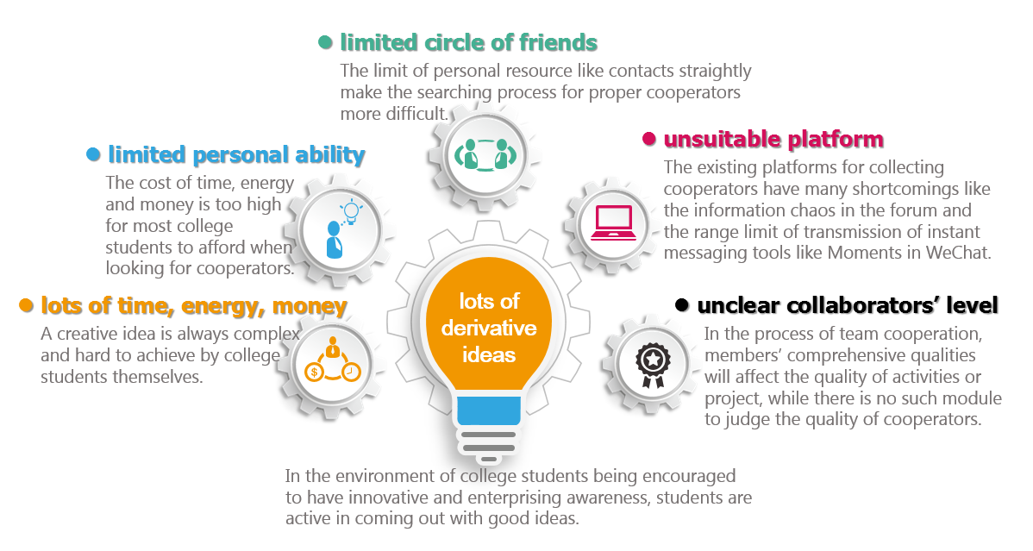

**1.2 Question Analysis**

We used fishbone casual method to analyze the concluded expression of which it is difficult for college students to find proper cooperators, and divided it into four parts(the starter，the cooperator, the cost, the platform). We can see from the environment that students are active in thinking and their creative and enterprising awareness are enhanced so great ideas spring up. However, it is hardly possible to make the idea come true if the student works alone without cooperators. On the other hand, during the process of searching for proper cooperators, a large amount of time, energy and money are needed, which becomes one of the reasons of that it is difficult for college students to find proper cooperators. In addition, there are few of the existing platforms for searching for cooperators on the market, and none of them is specially designed for college students, resulting in that great ideas can’t be finally achieved in the process of implementation.

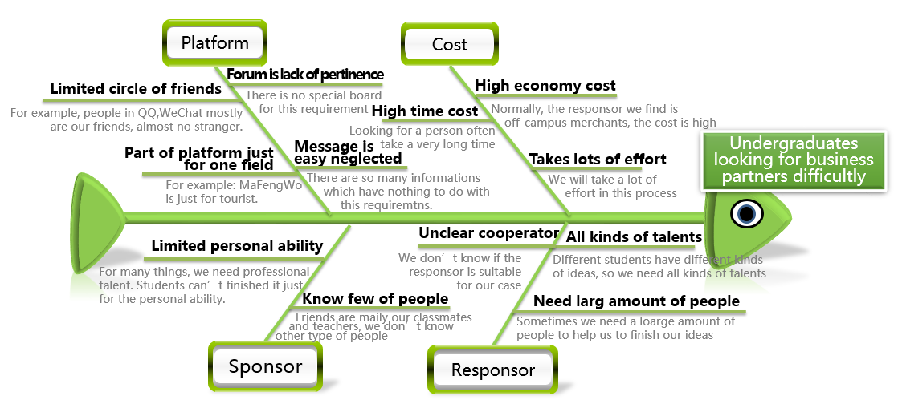

**1.3 Conclusion：Strangeraise platform**

After accessing to related resource, we learned that one of the important factors for helping students to achieve their creative ideas are convenient IT system and reasonable cooperator recommendation. Thus we wish that we can help to find proper cooperators for college students who have innovative ideas through a platform which is specially designed for college students with several modules, including project management, personal management, cooperator evaluation, project and cooperator recommendation and other, and besides supervise projects and activities based on these modules.

**1.4 Market Analysis**

**1.4.1 Related platform comparison**

The problem that it is difficult to find a good cooperator is common among not only college students but also other people. Several years ago, people found Crowdfunding to be difficult, so there came the platforms for Crowdfunding like zhongchou. However, the existing platforms for finding cooperators are not good enough, lots of disadvantages like information chaos, limit range of transmission, limit nature of activities and so on.

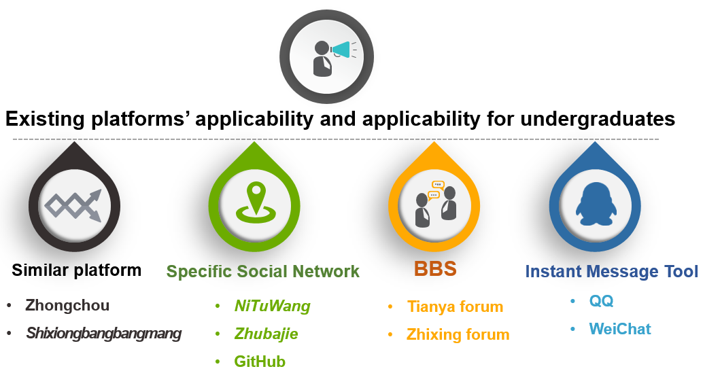

|  |  |  |  |  |
| --- | --- | --- | --- | --- |
| Platform | Cost | Applies to people | Advantage | Disadvantage |
| zhongchou | Free | Innovative people | 1. Low requirements makes it apply to most people; 2. Crowdfunding can be used in different fields, including technology, art, design, music and so on; 3. The professional platform 4. Increase the utilization of idle resource; | 1. Because of too much modules of Crowdfunding, there are some unreasonable phenomena in setting price for projects; 2. It can’t satisfy the need of college students for finding cooperators; |
| Brother! Help me | Free | College students | 1. Specific user population; 2. Help college students to use resource reasonably; | 1. The demanders have to be female and the implementors have to be male; 2. limit range of applications; 3. No evaluation module for implementors; |
| Tianya forum | Free | All people | 1. The forum is popular and has a large amount of users. Most of them are students. 2. This forum is rich in content; 3. Mature and effective community management module makes the atmosphere free and relaxed; | 1. No special modules used to raise people; 2. Too much clutter of information makes projects or activities easy to be ignored by users. 3. No quality evaluation for users in Tianya forum; |
| Zhixing forum | Free | Students in BJTU | 1. This is a popular campus website with many active users, which is a free platform; 2. The forum covers lots of fields; | 1. No special module for looking for cooperators; 2. The information update is too fast so the published information of raising people is easy to be ignored; |
| Specific interests social sites | Free | Specific amateurs | 1. Professional platform for raising people. 2. Users can share resource with other users; | 1. This site points at one specific group, so the range of application limits; 2. The forum’s users have much things in common, so it can’t satisfy the need of college students looking for cooperators in different kinds of fields; |
| Instant Messaging | Free | All people | 1. A large amount of users use instant messaging and college students rely much on these tools; 2. The immediate messages make users easier to see the published projects or activities; | 1. Limit of resource causes low utilization of idle resource; 2. Too frequent activity publishing bothers friends’ life; |

Through market research, we find that almost all platform are designed for Crowdfunding or some special activities. None of them can be used to help college students to achieve their innovative ideas.

First, we need to conclude the characteristics of college students looking for cooperators:

The students’ contacts limits, are usually students, too.

The students can’t have a basic understanding of the comprehensive qualities of cooperators found through some platforms with clutter of information.

Due to economic condition, students are more likely to use free products to complete their demands.

Generally, the implementation of a creative idea needs kinds of talents to work together, so there are some requirements for cooperators’ abilities.

These points mentioned above are the main characteristics of college students looking for cooperators. Based on these characteristics, we chose several popular platforms to analyze, and came out the advantages and disadvantages of these existing platforms and the advantages of the new platform:

|  |  |
| --- | --- |
| Advantages of the existing platforms | Project or activity release module;  Information real-time update, making it convenient;  Few limitations; |
| Disadvantages of the existing platforms | Information chaos and no such modules which manages the project release information;  No evaluation for cooperators;  Sites like *Mafengwo* are designed for people with some specific interests and can’t satisfy the requirements of college students; |
| Advantages of the new platforms | Has high pertinence and suitable for college students;  Designed mainly for college students, making tools more convenient;  Decrease the cost of students, feasible in economy; |

From the table above, we can see that for now, there is no such platform with high pertinence for helping college students to find proper cooperators, so MoChou, which is a platform designed for college students is promising theoretically.

**1.4.2 Stakeholder Questionnaire**

**1.4.2.1 Investigation Project**

To know that if our project does meet the requirement of market, we conduct an investigation. We enquire our schoolmates to find some drawbacks and improve it. Meanwhile, we consult to the businessmen for their cooperation intention to advance this platform itself, the advertising plan and the long-term interests. The full investigation plans follow:

**Time:** 10th April—12th April

**Respondent:** Students、Businessmen who related to students

**Approach:** Questionnaire (Details as per attached list 1、list 2)

**Content:** ①Issues that encountered by students when they seek for coordinators;

②Their knowledge and opinions on the platform for seeking coordinators;

③Businessmen’s expectations for this kind of platform.

**Budget:** No special investment.

**Purpose:** To know the requirement of students who search for innovative coordinators, find the problem of current similar platforms, provide solutions to these students, and develop a suitable platform for students who need innovative and original ideas to start a business. At the same time, we ask for the businessmen’s opinion on this type of platform and its feasibility in market.

**1.4.2.2 Data Analysis on the questionnaire for students**

Our questionnaires are geared to the students at school with 100 copies only. Students from other universities and colleges, which are drawing at random, wrote ten of them. And our schoolmates filled out 90 of the paper. To take all the things into consideration, we distributed the questionnaire according to the ratio of different faculties. Thus students in School of Electronic and Information Engineering, School of Information and Computer Technology, School of Economics and Management, School of Traffic and Transportation, School of Civil Engineering, School of Mechanical, Electronic and Control Engineering, School of Electrical Engineering, School of Science finished 10 of them; students in School of Language and Communication Studies, School of Software Engineering completed 7 of them; and the last 6 copies are filled out by Law School students.

We can conclude from the above graph:

1) College students are active in thinking at large that they have many innovations and new ideas.

2) Most students can’t or don’t make these ideas come true.

3) They are confined by their relationship circles or regions, and tend to use QQ、We chat and other school forum to seek coordinators.

4) Mostly, they would need a high time cost, nearly three days to find a partner.

5) Most students say that it is a tough job to find a suitable coordinator.

6) The cost to find such a suitable person is about 300 Yuan.

7) A large amount of students are dissatisfied with current platforms.

Analysis on Current Platform

1) Some students know this kind of platform, but only a small part of them have used it.

2) Those who have tried the current platforms claimed that these platforms couldn’t meet the real demand.

3) Basically, the main users of such platforms are not only students, so different people from different positions and information itself may pile up.

**1.4.2.3 Data Analysis on the Questionnaire for Businessmen**

Our team mainly aimed at students at school and shoppers related to student including Class Box (An App for students to record their curriculum schedule)、XinChengge Stationery (A stationery around our school)、77help.cn (A multi-helper on Wechat in our school).

We distributed 50 copies of questionnaire to the business areas that related to students, including catering services, entertainment industry, App for learning, stationery and sports goods. We have contact those shoppers like MianHe ChaoChou, Class Box, XinChengge and print shops in our campus and make detailed investigation. Concrete analysis as follows:

After deep consideration and patient analysis, we get the above table. We can notice that:

1) To enlarge its market, shoppers are willing to cooperate with platform through advertisement or leaflets in most cases.

2) Most shoppers would like to advertise themselves when they have enough money if there is someone contact them forwardly.

3) In general, 1000 Yuan is an acceptable amount of money for shoppers to invest.

4) Most of the shoppers are not content with the current result of advertising and hope to find a better way or platform.

5) If there is about 10000 visitor in a website or a platform, shoppers would like to advertise on it.

6) Shoppers have a positive opinion on the platform and are ready to collaborate in this way, which the platform provide access to the shoppers.

After the investigation, we find that, students do need such a platform to find a suitable coordinator to fulfill their innovations and ambitions. However, such need hasn’t been satisfied up till now. What’s more, shoppers are willing to cooperate with such platform to gain mutual benefit. So, our platform is in need now and will have profits in future.

**1.5 The Scope of Business**

We have mentioned in the above context that students are encountered with the following problems when they seek for coordinators to fulfill their dreams:

1) College students are active in thinking at large that they have many innovations and new ideas.

2) Different people are conferred to different skills, and in certain skills or capacity, there’re gaps.

3) The team spirit has a direct influence on the final result.

4) Students tend to employ free products rather than those are in charge.

5) They are confined by their relationship circles or regions, and tend to use QQ、We chat and other school forum to seek coordinators.

6) The cost of current way to find such a suitable person is high in time and energy.

According to these problems, survey on the students at school and businessmen, analyses on the existing products, we come to the conclusion that our platform are divided into five parts. They are Project Management、Personal Management、Assessment of Members、Recommendation and Diary. The part of Personal Management deals with the batch of users and individuals. And in the recommendation part, we will entail different courses labels、suitable coordinators and fine projects. The specific structures are as follows:



**1.6 The Vision**

After the analyses and reflection, we come up with a slogan and the vision of our project, which is “Innovation, Creation and Enterprising; Melting Intelligence, Financing and Integrating”.

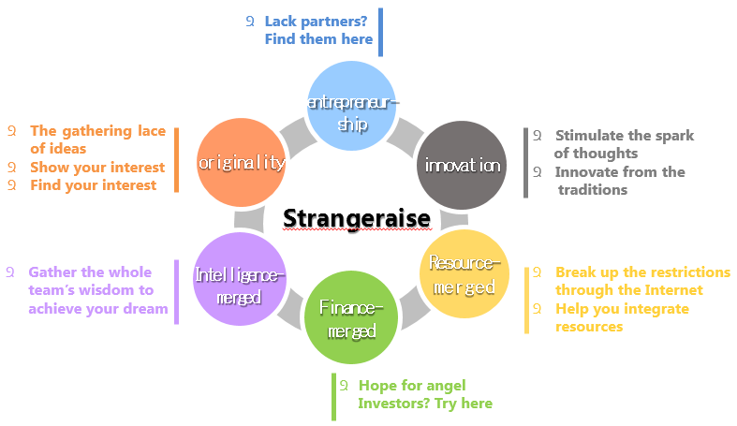

At present, college students are confined by their network, regions and personal abilities. At the same time, the existing platforms have many problems in real life. So we hope that on our platform, these students can find a suitable coordinator and finish their dreams and ideas together. We encourage students to exert their skills and abilities fully, cultivate the sense of creativity; and we also work as an observer of the whole process, to foster their team spirits and broaden their eyesight.

**1.7 Feasibility** **Analysis**

**1.7.1 Stakeholder** **Analysis**

At the same time, taking into account the late profit, our team believes that there are four relevant stakeholders, and they are students (including project sponsors and project partners), service providers, advertisers and school. Through the analysis of different roles, we identified the key requirements. As follows:

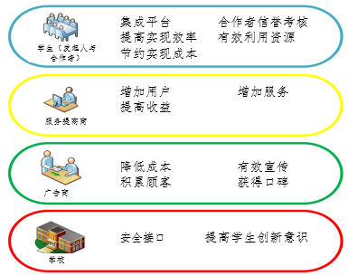

That is, students need to find a right partner through such a platform to achieve innovation and entrepreneurial ideas; to help students achieve the saving of cost and increase of efficiency; project initiator can find a partner with minimal cost through this platform; project partners can fully play to their talent and cultivate teamwork in the cooperation process; service providers want to increase the amount of users, increase service and expand their income; advertisers hope to advertise through this platform with less money and get a more effective publicity; schools hope that this platform can improve students' awareness of innovation, and is also safe.

**1.7.2 SWOT Analysis**

By the comparison between external factors and internal factors, the team got the strengths and weaknesses, opportunities and threats of the project, and also made a preliminary response strategy. The first table on the next page will talk about it in detail.

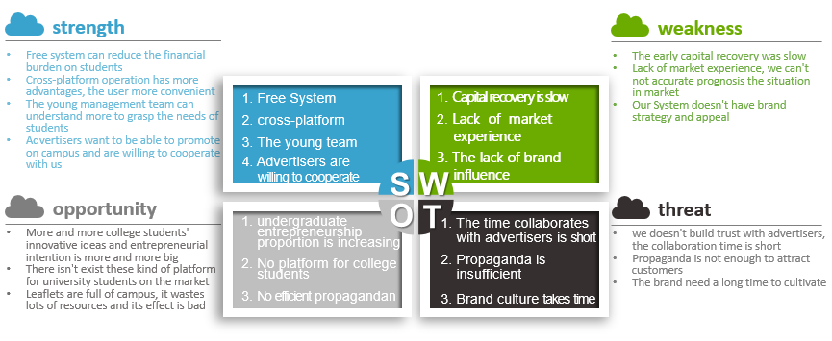

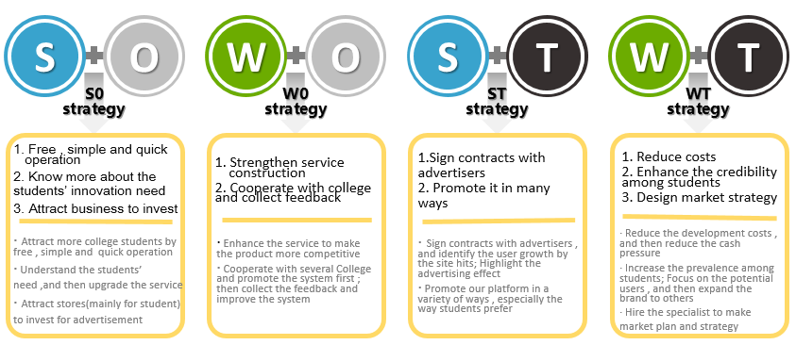**1.7.3 Potential Value**

After discussion, the team presented the potential value of this project to different stakeholders in four areas, the economy, team management, resources, and collaboration capabilities. The second table on the next page will talk about it in detail.

|  |  |  |  |  |
| --- | --- | --- | --- | --- |
| Stakeholder | Financial | entrepreneurship | source | growth learning |
| Student sponsor | Use the platform freely, which can save the cost. | Seek for a suitable cooperator efficiently and achieve one self’s innovations. | Offer an innovation and let others know it by the platform. | Find partners who are in the same camp and learn from each other, broaden one’s eyesight. |
| Student cooperator | Increase income to some degree. | Find partners who are in the same camp and finish their dreams. | Melt the different people in the same platform. | Seek a suitable partner and learn from each other. |
| Service Provider | Attract more users and increase profits. | Provide more services according to the feedback; help them to fulfill their dreams; to assemble different ideas. | Provide a free platform to help college students find a suitable coordinator. | Seize the opportunity and help the college students fulfill their dreams. |
| Advertisers | Aim at a certain group of customers to gain more downloaders and visitors. | / | Reduce the cost to print leaflet; provide a software or agency for students on their life and study. | Increase the brand awareness, gain more customers, and enhance the competitiveness. |
| Schools | / | Provide the basic information of student; initialize the students’ accounts in batch; encourage more students to start their own business. | Reduce the students’ cost on this issue (including time, energy and money); provide the chance for them to make a balance between study and enterprise. | Improve students’ awareness of enterprising; lead the reform of higher education. |

**1.7.3 The Schedule of Value Return**

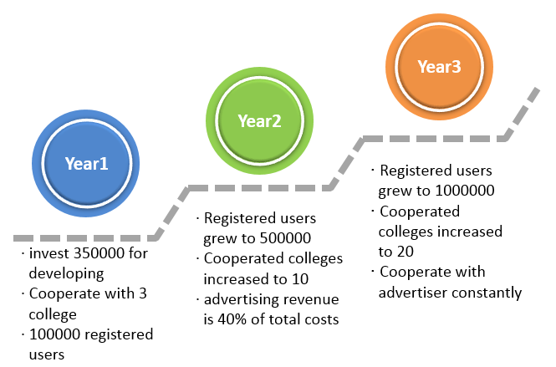

|  |  |
| --- | --- |
| Year 1 | We estimated that the initial investment is about 350000 to develop web platform and mobile phone client. In the first year, the platform will be put into use within the region and promotion, and accumulate experience.  We aim to broaden the market and attract more students or schools users through the convenient services; we also expect to cooperate with three schools, and gradually improve the service and gain about 100000 registered users for the first year. |
| Year 2 | The second year, through continuous promotion and service optimization, we want a number of 500000 registered individual users and the school group type users reached 10; at the same time, we learn to seek cooperation with businessmen and gain about 40% of the cost from advertisers. |
| Year 3 | In the third year, we will maintain and upgrade relatively mature service system, develop new services and features from user feedback. The registered users will increase to 100 million and the collective type of users will reach 20;we keep up with the advertiser's cooperation and form a network around universities model. We will reclaim our cost this year. |

**1.8 Solution**

**1.8.1 Proposed solution**

On the basic of analyzing the software system, we provide three solutions to construct this whole software system.

**1.8.1.1 Solution 1 — Outsource to Software Company**

We have learned several internal software outsourcing companies: Yiyibei, MaesInfo, era of Hualu, Shanghai Weaver. In the ways of searching online, consulting by phone and other ways, we got some information of these companies about cost, quality, time, reputation of their products. According to these aspects, we did a comparative analysis, which is specifically listed in the table on the next page.

From the table on the next page, we can get that: The bigger the software outsourcing company and the better the market valuation of the company, the higher its price for outsourcing, and the more guaranteed the quality, the security and the deliver time. If we choose to outsource to software companies, the balance of quality and price has to be considered.

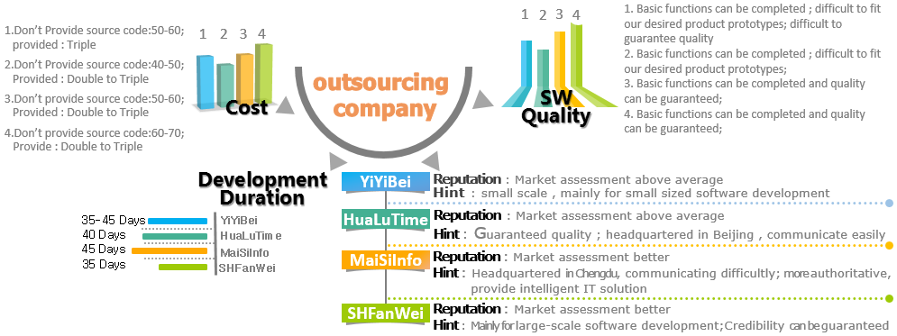

|  |  |  |  |  |  |
| --- | --- | --- | --- | --- | --- |
| Company | Cost | Quality | Time | Reputation | Comments |
| Yiyibei | Less expansive;  No source code: If the number of users is less than 100, the price is 300-400 thousand; the price is 500-600 thousand if not considering the number of users;  Providing source code: 3 times as much as the price above; | Basic functions can be completed, but some of them don’t fit the product prototype, so the quality can’t be guaranteed; | 35-45 workdays | Average | Company is small, which mainly aims at developing medium or small size software. It’s possible that the deliver being deferred; |
| Era of Hualu | More expensive; maintaining and update need extra charge;  No source code: The price is 400-500 thousand; Providing source code: 2-3 times as much as the price above; | Basic functions can be completed, but some of them don’t fit the product prototype; | Within 40 workdays | Above average | Fortune 100 software outsourcing companies in China; products’ quality is guaranteed; The company's headquarters is based in Beijing, so it’s convenient to communicate with them; |
| MaesInfo | More expensive; update need extra charge;  No source code: The price is 500-600 thousand; Providing source code: 2-3 times as much as the price above; | Basic functions can be completed, and quality can be guaranteed; | Within 45 workdays | good | This company is a innovative service company which offers professional intelligentized IT solutions for well-known global companies; It is authoritative, but its headquarter is based in Chengdu, and has no branch in Beijing, leading to the difficulty of communication; |
| Shanghai Weaver | More expensive; maintaining and update don’t need extra charge;  No source code: The price is 600-700 thousand;  Providing source code: 2-3 times as much as the price above; | Basic functions can be completed, and quality can be guaranteed; | Within 35 workdays | good | This company mainly aims at developing medium or large size software, having a series of its own OA(Office Automation) products; The company has high credibility with lots of successful cases; In addition, it owns a business-oriented multi-user TODO tool-“E-teams”; |

**1.8.1.2 Solution 2 — Use open-source software to construct a new system**

Through survey, we learned that there are a few frameworks online for raising people, and the frameworks for raising money and raising people are similar. Thus, we chose several open-source frameworks which fit the developing demand of our project to compare and analyze, specifically expressed by the table below.

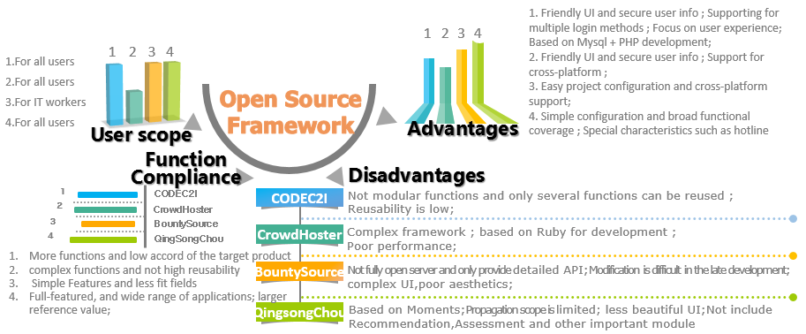

|  |  |  |  |  |
| --- | --- | --- | --- | --- |
| Software | User type | Conformity | Advantage | Disadvantage |
| CODEC2I | Common people | Has many functions but them does not fit target products well; | Friendly interface;  Users’ data is secure;  Support several ways of logging in;  Pay much attention to user experience;  Use Myspl+PHP to develop products; | No modular functions, only several functions can be reused; |
| CrowdHoster | Common people | Functions are complex with low reusability; | Many functions;  Concise interface;  Cross-platform support; | Complex system framework;  Use Ruby language to develop the project;  Bad system performance; |
| BountySource | People who work in IT | Functions are simple; can be used in only one field; | Simple configuration;  Cross-platform support; | The web background is not entirely open source, but only the specific APIs are provided, so it is difficult to modify it later;  Interface is complex and inaesthetic; |
| Easy to raise | Common people | Has all general functions, and a wide application field; It has great reference value; | Wide coverage of functions;  Has special features like customer service; | Service platform based on Moments in WeChat, so diffusing itself is limited;  The interface is not good enough, and has no recommendation module, evaluation module, and other important modules; |

**1.8.1.3 Solution 3 — Independently develop**

Based on PHP, follow the style of software architecture, use principles of package design and object-oriented principles, and adopt proper design patterns according to different situation.

Using agile development, specific demands during the developing process, and develop the software system as soon as possible on the premise of ensuring quality.

We set up a develop team with five members, developing an integrated software system which has full functions, is easy to maintain, and can satisfy the project demands of college students in three months.

**1.8.2 Deep analysis for solutions**

**1.8.2.1 Demands、Constraints、Stakeholder analysis**

The team did some analysis about the three solutions in ways of demands, constraints and interest. Table is on the next page.

**1.8.2.2 Budget evaluation**

We can learn from the analysis above, three solutions all have pros and cons. In order to compare and analyze this three solutions and finally decide to choose which one, our team did a brief budget estimate of the three solutions.

We looked up plenty of information and data and made out the budget evaluation of out platform for the first three years (listed in the second table on the next page). Part of the data in the table is referred to data in software industry norm database from 2014 to 2015, part of it comes from the experience of that students in Software School engage in some projects got from companies, that student organizations try to get sponsor, and so on.

|  |  |  |  |
| --- | --- | --- | --- |
| Solution | Satisfiable demands | Constraints | Influence to Stakeholder |
| Solution 1 Outsource | 1. Can be fast put into use; 2. Product’s quality can be guaranteed; 3. Less development costs; | 1. Bad products’ flexibility; 2. Low demand coverage; 3. Poor extension performance of functions can’t satisfy possible new demands; 4. Later maintenance costs more; 5. Hard to update version; | * 1. Service providers: In early stage, a shaped product can be got by paying relatively a little money, but this product can’t satisfy the increasing demands or can’t be updated as the company has no developers itself. If the product can’t be updated in time, it will affect the impression of students so it is harmful for further development;   2. Students: If the functions can’t be updated or improved, experience of students will be greatly reduced; |
| Solution 2 Use open-source software | 1. Products are relatively mature, and quality of which is almost the same as business software, and it costs less than business software; 2. Secondary development is possible, and the desired functions can be implemented, so this solution has much freedom; | 1. Product may not be consistent with business in companies, so business functions may need further modification; 2. According to some open source license, secondary development must be open source if use open-source software, or may cause tort, a business risk; | 1. Service providers: In early stage, a shaped product can be got and put into use by paying relatively a little money, but could have the risk of tort; By accumulating experience of technological development in early stage, a group of developers are trained so cost of maintenance later will be low; 2. Students: Can give feedback of desired experience in time to enhance the efficiency of team management; |
| Solution 3 Independently develop | 1. Products can be 100% made out as designed, which is flexible; 2. Easy for later extending demands and maintenance; 3. Train a group of technical talent for enterprise as new resources; | 1. Cost of development is high, and it is inefficient at the beginning, and products can’t be made out in a short time so payback period will be long; 2. Risk of lack of experience may lead to that the product can’t satisfy the market standard; | 1. Service providers: Improving the flexibility of projects, products can be adjusted according to the demands of students in time, thus to increase user agglutinant, then can attract advertising partners by the use of a large amount of users, and finally achieve commoditization; When getting products, technological talent can be trained as new resources; |

|  |  |  |  |
| --- | --- | --- | --- |
| Project costs | Solution 1 | Solution 2 | Solution 3 |
| Cost of constructing the platform  (RMB) | Outsourcing development（1000 RMB/function point * 300 function points）+ server 20,000 + average hosting fee 3,500 RMB/year * 3 = 330,500 | Software cost 0 + modification and moving cost 30,000 + Constructing the developing office 150,000 + salaries for four developers 8,000 RMB/month * 2 * 4 + salaries for two testers 6,000 RMB/month * 2 * 2 + server 20,000 + average hosting fee 3,500 RMB/year * 3 = 298,500 | Constructing the developing office 150,000 + salaries for four developers 10,000 RMB/month * 4 * 2 + salaries for two testers 6,000 RMB/month * 2 * 2 + server 20,000 + average hosting fee 3,500 RMB/year * 3 = 212,500 |
| Cost of maintaining the platform  (RMB) | (Repair major BUG 80,000 RMB/year + salaries of fixed maintainers 5000 * 12 RMB/year) * 3 = 420,000 | (salaries of fixed maintainers 8000 *3* 12 RMB/year ) = 288,000 | (salaries of fixed maintainers 8000 * 2 * 12 RMB/year ) = 192,000 |
| Cost of advertisement (RMB) | Online advertisement 20,000 * 3 + offline advertisement 50,000 * 3 = 210,000 | Online advertisement 20,000 * 3 + offline advertisement 50,000 * 3 = 210,000 | Online advertisement 20,000 * 3 + offline advertisement 50,000 * 3 = 210,000 |
| Total cost of the first three years  (RMB) | 960,500 | 796,500 | 614,500 |

**1.8.2.3 Risk evaluation**

In order to better evaluate the risk of three solutions above, we listed the following related risk factors, and defined table of the levels of risk for quantifying values of risks of the three solutions:

|  |  |  |  |  |
| --- | --- | --- | --- | --- |
| High | Average | Low | Very low | Zero |
| 4 | 3 | 2 | 1 | 0 |

Comparison of risks of all solutions：

|  |  |  |  |
| --- | --- | --- | --- |
| Risk factor | Solution1 | Solution2 | Solution3 |
| The number of users can’t meet the standard | 3 | 1 | 1 |
| Coefficient of developing difficulty | 1 | 2 | 3 |
| Excessive of budget | 2 | 1 | 2 |
| Excessive of constructing the platform | 3 | 2 | 3 |
| Risk of products copyright | 1 | 3 | 1 |
| External attacks to the system | 4 | 3 | 2 |
| Difficulty of maintenance and update in the later stage | 4 | 2 | 1 |
| Bad effect of advertisement | 2 | 1 | 1 |
| Sum of risks | 20 | 15 | 14 |

Generally speaking, the risk of solution 1 is the lowest, while that of solution 1 is the highest.

**1.8.2.4 Conclusion**

Through an overall analysis to these three solutions, we can see that every solution has its own strong points. But we still found some problems after analyzing:

Solution 1: Though development investment is small, but cost of maintenance and update in the late stage is uncontrollable, as well as limit flexibility, low extension and having no control to the system;

Solution 2: Although under high risk of copyright, it’s safe if follows open source licenses like MPL, BSD, QPL, QNCL, and so on; And in the late stage, maintenance is easy as we work out the project independently. By the way, in the aera of internet, we have to be faster than others to take an advanced status. Therefore, this solution is feasible.

Solution 3: It has high developing efficiency and low cost; Flexible and custom demands.And with the reason that it is developed by ourselves, the model we spend a lot of time to work out may not as good as products worked out by solution 2.

Generally consider all solutions, solution 3 is the most flexible solution, while solution 3 is the most valuable solution. Therefore, we recommend solution 3.

**1.8.3 ROI analysis of the solution**

**1.8.3.1 Foundational assumption**

|  |  |
| --- | --- |
| Foundational assumption | Value |
| User growth rate（/year） | 40% |
| Active user rate（/day） | 70% |
| AD click rate | 1% |
| Bonus for users’ clicking ad（/time） | 0.01 |
| AD growth rate（/year） | 20% |
| Initial number of ad | 100 |
| Initial cost of one-off ad | 3000 |
| Growth cost rate of one-off ad（/year） | 3% |
| Initial number of users | 5000 |
| Tax rate | 35% |
| Discount rate of case | 0.40% |
| Weighted Average Cost of Capital(WACC) | 12% |

**1.8.3.2 Analysis of one-year transactions of basic cases**

|  |  |  |  |  |
| --- | --- | --- | --- | --- |
| Project | Initial state | The first year | The second year | The third year |
| Number of users | 5000 | 7000 | 9800 | 13720 |
| Number of ad |  | 100 | 103 | 106 |
| Number of active users |  | 1176000 | 1646400 | 2304960 |
| Number of users’ clicks |  | 11760 | 16464 | 23050 |
| Baseline income |  | 300117.60 | 309164.64 | 318500.50 |
| Cost of initial construction | 200000 |  |  |  |
| Maintenance, update and advertisements |  | 137500 | 137500 | 137500 |
| Net income |  | 162617.60 | 171664.64 | 181000.50 |
| Capital discount |  | 650.47 | 686.66 | 724.00 |
| Profit |  | 161967.13 | 170977.98 | 180276.49 |
| Net income after tax |  | 105278.63 | 111135.69 | 117179.72 |
| Compensation of depreciation turning back |  | 650.47 | 686.66 | 724.00 |
| Cash flow after tax | -200000 | 105929.10 | 111822.35 | 117903.72 |

**1.8.3.3 Incremental cash flow**

|  |  |  |  |  |
| --- | --- | --- | --- | --- |
| Project | Initial state | The first year | The second year | The third year |
| Net cash flow growth | -200000 | 105929.10 | 111822.35 | 117903.72 |
| Net present value(NPV) | 67645.20 |  |  |  |
| Weighted average cost of capital(WACC) | 12% |  |  |  |
| Tax rate | 35% |  |  |  |
| Internal rate of return for 3 years(IRR) | 30% |  |  |  |

**1.8.3.4 Investment pay-back period**

|  |  |  |  |  |
| --- | --- | --- | --- | --- |
| Project | Initial state | The first year | The second year | The third year |
| Net cash flow growth | -200000 | 105929.10 | 111822.35 | 117903.72 |
| Cumulative cash flow |  | -94070.90 | 17751.45 | 135655.17 |
|  | 11 | of year 2 | 🡺 | 0.84 |
| Payback period(PBP) |  |  |  | 1.84 |

**1.8.3.5 Analysis and conclusion**

We can easily get the conclusion according to analysis of cost, income and rate of return on the investment of IT solution:

NPV is 67,645, which is larger than 0;

IRR is 30%, which is larger than WACC;

The cumulative cash flow will be 135.7 thousand in the third year.

In conclusion, this IT solution is feasible.

**2 project startup**

**2.1 System development methods and key steps**

In this program, we use object-oriented analysis method and object-oriented design method, with UML modeling tool. In the stage of design, we draw the internal modeling diagram by analyzing the business flow, and work out the the overall architecture design and the detailed design to each subsystem as the picture below. The object-oriented method is the analysis and design method based on the concept of the object, which believes that information system is a set of objects which are combined under different levels of abstraction. We will describe the objects in the system, the attributes and operations of the bojects, the dynamic characteristics of objects, construction relation and correspondence relationships of objects, and thus construct the static structure of the system and the model of dynamic activities.

|  |  |  |
| --- | --- | --- |
| **Development Tools** | Sublime Text / WebStorm / PhpStorm | |
| **technical route** | The whole website uses frameworks of MVC and thinkphp to develop, following the principles of package design of thinkphp strictly, well implementing the separation of front end and background. Two sides can be developed at the same time, making it efficient with strong maintainability. | |
| Front end | The whole website uses frameworks of MVC and thinkphp to develop, following the principles of package design of thinkphp strictly, well implementing the separation of front end and background. Two sides can be developed at the same time, making it efficient with strong maintainability. |
| Back end | Back end uses thinkphp to read and operate Model, and the control layer inherits class “controller”, having corresponding logic functions of operative class ”Controller” to each Model. |

The basic steps of object-oriented analysis are: the statement of problem domain, identify objects and classes, determine attributes of objects, determine service of objects, and determine the relation between objects and class. In the object-oriented design stage, the specific task is to first identify and arrange interface objects, and then identify control objects, and then identify the relation between ensure the entity objects, interface objects and control objects, and finally design the system structure.

**2.2 Scope model**

**2.2.1 Context model**



**2.2.2 Conceptual model**

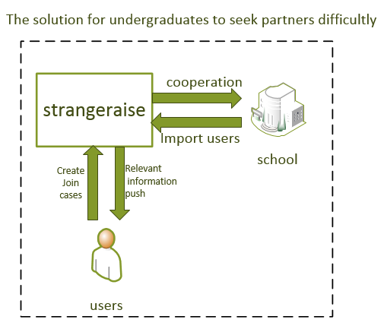

**2.2.3 Problem-object model**

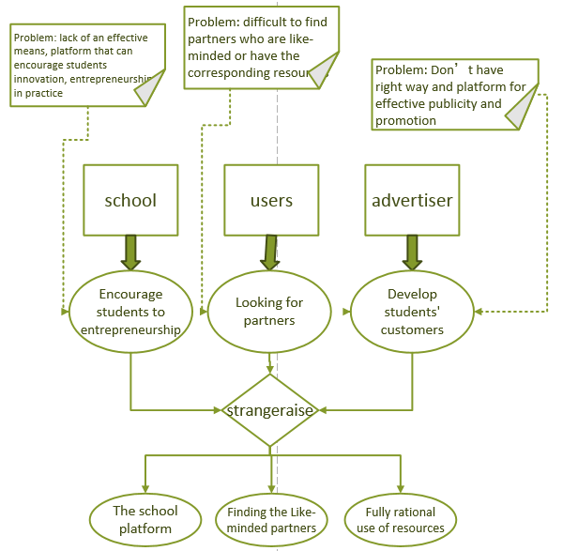

**2.3 Business Use Case**

**2.3.1 Use case model**

By earlier analysis, we found that to that college students look for cooperators, main business can be some modules including personal management, project management, member evaluation, recommendation, and log management.



**2.3.2 Statement of personal use case**

**2.3.2.1 Personal management**

|  |  |  |  |
| --- | --- | --- | --- |
| **User case name** | User information management | | **Business demands of user case type** |
| **User case ID** | BC001 | |
| **Main business participators** | Capteam，Users | | |
| **Other participators** | Colleges | | |
| **Interests of related people of the projects** | **Capteam**: Wish to get users’ information and save it; or cooperate with colleges, and register in bulk with information provided by colleges like student IDs;  **User** : Wish operations like convenient register, log in, modification without too many steps;  College: Wish to cooperate with Capteam, and register in bulk with information provided by colleges like students ID; | | |
| **Description** | This user case describe all referred events in management of user information on Capteam; | | |
| **Precondition** | Capteam and colleges have to reach an agreement on cooperation, and colleges have already provided informations of teachers and students to Capteam; | | |
| **Post condition** | Capteam updates data of the database by inserting, deleting, modifying, and searching of user informations; | | |
| **Trigger conditions** | Users do operations like registering on Capteam;  Capteam and colleges reach an agreement on cooperation and colleges provide informations of teachers and students to Capteam; | | |
| **Basic flow** | Action participators | System response | |
| 1.1 Users enter username, password and other informations on Capteam to finish register; | 1.2 The system makes sure that this username hasn’t been used, and save s information;  1.3 Jump to log in page; | |
| 2.1 Users enter information like the password that needs to be modified on Capteam; | 2.2 The system makes sure information and updates database; | |
| 3.1 Capteam and colleges reach an agreement on cooperation and colleges provide informations like students ID to Capteam;  3.2 Register of system managers in bulk; |  | |
| **Extend process** | Replace steps 1.2—1.3：  1.2 System judges that data is illegal, and returns error information;  1.3 Jump to register page;  Replace steps 2.2：  2.2 System judges that data is illegal, returns error information, and doesn’t update new data; | | |
| **End** | End after succeeding in adding or updating user information; | | |
| **Business rules** | Usernames have to be unique;  Users can register by themselves on the platform to get an account, as well as get one by system managers register in bulk; | | |
| **Constraints and instructions** | Manager user informations on Capteam; | | |
| **Assumption** | Colleges are willing to provide informations like students ID; and all informationa are real and reliable; | | |
| **Unsolved problems** | None | | |

**2.3.2.2 Project management**

|  |  |  |  |
| --- | --- | --- | --- |
| **User case name** | Project management | | **Business demands of user case type** |
| **User case ID** | BC002 | |
| **Main business participators** | Capteam，Users | | |
| **Other participators** | None | | |
| **Interests of related people of the projects** | **Capteam**: Wish to get users’ information and save it; Wish to get related project informations including human resource and others to deal with and save; Wish to get data like arrangement progress to save and do related operations, and come out corresponding operations according to these data;  **Users** : Wish to use simple operations to manage projects; | | |
| **Description** | This use case describes related events in the project management module on Capteam; | | |
| **Precondition** | Users have already registered on the platform; project members have been ensured, and project schedule, plans and others have been discussed; | | |
| **Post condition** | Update person information, other resource information, project schedule, and other information by dealing with input date from users and make operations like quality control and project progress according information like project pregress saved by system; | | |
| **Trigger conditions** | Users choose to create a new project;  Users enter project members’ information and other resource information;  Users enter project schedule;  Time nodes in the project schedule are coincident with system time;  The group leader evaluates the task completion after one task of the project is completed; | | |
| **Basic flow** | Action participators | System response | |
| 1.1 Users choose the operation of creating a new project, and enter information of this new project; | 1.2 The system handles the entered information, save it into database and the person who create a new project is defaulted to the group leader; | |
| 2.1 Users information about team members, and other resources on a specific project on Capteam; | 2.2 The system selects kinds of resources into this project based on entered information, and handles and saves members information;  2.3 The system sends message to related people; | |
| 3.1 Users enter the project schedule in a specific project on Capteam; | 3.2 The system handles the project schedule information and save them and forms the project Gantt chart; | |
|  | 4.1 When the schedule time of the project equals the system time, the system will send messages to related users that remind users of unfinished task; | |
| 5.1 The group leader evaluates every completed task finished by members; | 5.2 The system judges the completion of the whole system, handles the data based on some formulas and saves the data; | |
| **Extend process** | Replace step 1.2：  1.2 The system judges related data of the project is illegal, so stops the operation of creating project, and return to creation interface;  Replace steps 2.2—2.3：  2.2 The system finds errors in the information of members or other resources, so stops the current operation and return the error;  Replace step3.2：  3.2 The system finds error in information of project schedule, so stops operations, and return error; | | |
| **End** | End after succeeding in adding or updating user information; | | |
| **Business rules** | Usernames have to be unique;  Group members are determined offline, and project schedule has been initially discussed;  Group members have all registered on Capteam; | | |
| **Constraints and instructions** | There might be errors between the progress of project schedule which is judged and the actual completion; | | |
| **Assumption** | Group members are determined offline, and project schedule has been initially discussed;  Group members have all registered on Capteam;  The formula for evaluating the quality supervision of the project is correct and objective;  All entered data is correct and meet the standard of the system; | | |
| **Unsolved problems** | None | | |

**2.3.2.3 User management**

|  |  |  |  |
| --- | --- | --- | --- |
| **User case name** | Evaluation management | | **Business demands of user case type** |
| **User case ID** | BC007 | |
| **Main business participators** | Capteam，Users | | |
| **Other participators** | Member | | |
| **Interests of related people of the projects** | **Capteam**: Wish to get deadline, completion and other information entered by users and thus calculate the personal evaluation based on the formulas;  **sponsor** : Wish to automatically evaluate every member according to the personal completion by the group leader himself;  **responsor** : Wish to give a equitable, accurate evaluation for himself; | | |
| **Description** | This use case describes related events in the user management module on Capteam; | | |
| **Precondition** | Users have already registered on the platform;  Users have joined the desired teams and projects; | | |
| **Post condition** | The system calculates the personal evaluation based on the formulas according to the time to complete the task, the completion, the workload and so on; | | |
| **Trigger conditions** | Leader finishes the evaluation of the completion of one task; | | |
| **Basic flow** | Action participators | System response | |
| 1 Leader checks the finished tasks uploaded by members and gives evaluation of the tasks; | 2 Capteam handles the received data and saves in into the database;  3 Capteam calculated the evaluation of related people based on some formulas and saves it; | |
| **Extend process** | Replace step 3：  3 Capteam judges that the group leader doesn’t believe that the task has been done, and don’t do the operation of evaluation; | | |
| **End** | End after succeeding in updating all evaluation of members; | | |
| **Business rules** | Leader needs to set the workload, deadline of the tasks and related information about evaluation when publishing the tasks;  After member uploads the finished tasks and leader comfirms that the tasks have been done, Cpateam will evaluate the member based on the deadline, the actual complement day, evaluation from the leader and other data according to some formulas; | | |
| **Constraints and instructions** | Accuracy of the formula for calculating the evaluation needs to be evaluated; | | |
| **Assumption** | Leader gives the equitable, accurate completion evaluation;  The formula for calculating the evaluation is basically corrent, the error is acceptable;  All the treatment and saving progresses of the data are correct with no errors; | | |
| **Unsolved problems** | None | | |

**2.3.2.4 Recommendation**

|  |  |  |  |
| --- | --- | --- | --- |
| **User case name** | Message management | | **Business demands of user case type** |
| **User case ID** | BC009 | |
| **Main business participators** | Capteam，Users | | |
| **Other participators** | None | | |
| **Interests of related people of the projects** | **Capteam**: Wish to remind users of unfinished tasks or conferences;  **responsor**: Wish the system can remind himselfof unfinished tasks or conferences or messagesrecently in time;  **sponsor**: Wish the arranged tasks can be noticed to all related people; | | |
| **Description** | This use case describes related events in the message management module on Capteam; | | |
| **Precondition** | Users have already registered on the platform;  Users have joined the desired teams and projects; | | |
| **Post condition** | When that the leader publishes new tasks or notice about conferences, that the time nodes in the personal schedule is close to the system time, that submitted tasks have been evaluated, and that other things happen, the system will send messages automatically to remind the user; | | |
| **Trigger conditions** | The leader publishes new tasks or notice about conferences; the time nodes in the personal schedule is close to the system time; the submitted tasks have been evaluated or ensured; | | |
| **Basic flow**  **Extend process** | Action participators | System response | |
| 1 One of the trigger conditions happens; | 2 The system send messaged to all related users automatically; | |
| **End** | None | | |
| **Business rules** | End when the messages are successfully sent; | | |
| **Other participators** | When the system detects that he leader publishes new tasks or notice about conferences, that the time nodes in the personal schedule is close to the system time, that the submitted tasks have been evaluated or ensured, the system will send messages automatically to all related people in order to remind users in time; | | |
| **Constraints and instructions** | Users may not notice the messages sent by the system in time; | | |
| **Assumption** | Users will check the messages online on time, thus to make sure that they can see the messages in time;  The system can detect all the trigger conditions accurately and correctly find all the related people and send messages to them;  All the handled data and saving progresses are correct without errors; | | |
| **Unsolved problems** | None | | |

**3.3.2.5 Log**

|  |  |  |  |
| --- | --- | --- | --- |
| **User case name** | Personal schedule management | | **Business demands of user case type** |
| **User case ID** | BC004 | |
| **Main business participators** | Capteam，Users | | |
| **Other participators** | None | | |
| **Interests of related people of the projects** | Capteam: Wish users can input personal schedules as part of the data of the schedule management, in order to better implememt functions like online meeting;  Users : Wish to import personal schedules into the system conveniently by some simple operations so the group activities like discussion would be easier; | | |
| **Description** | This use case describes related events in the personal schedule management module on Capteam; | | |
| **Precondition** | Users have already registered on the platform; | | |
| **Post condition** | Capteam handles the personal schedule inputed by users and save it to the user’s schedule; | | |
| **Trigger conditions** | The operations that users choose to add, modify or delete the schedule; | | |
| **Basic flow** | Action participators | System response | |
| 1.1 Users input personal schedule, and send data to the server of Cpateam; | 1.2 The system judge the type of operation after receive the data;  1.3 According to the operation type, the system handles the data and save it into corresponding place in the database; | |
| 2.1 Users modify some existing personal schedules and send the modifies data to the server; | 2.2 The system judge the type of operation after receive the data;  2.3 According to the operation type, the system handles the data and save it into corresponding place in the database; | |
| 3.1 Users choose one personal schedule, and choose the delete operation; | 3.2 The system judge the type of operation after receive the data;  3.3 According to the operation type, the system handles the data and updates the database; | |
| **Extend process** | Replace step 1.3：  1.3 The system judges that the information is not corrent, so to stop the current operation and return errors;  Replace step 2.3：  2.3 The system judges that the information is not corrent, so to stop the current operation and return errors;  Replace step 3.3：  3.3 The system judges that the information is not corrent, so to stop the current operation and return errors; | | |
| **End** | End after succeed in adding or updating the personal schedule; | | |
| **Business rules** | The personal schedule inputed by users can’t be conflicted with existing schedules;  Users need to judge the correctness of inputed schedules; | | |
| **Constraints and instructions** | It can’t be judged if the personal schedule inputed by users is correct or not; | | |
| **Assumption** | The personal schedules inputed by users meet the actual situation;  The format of personal schedules inputed by users are legal, correct, and conformable to the specification;  The server works successfully when dealing with the data, and save the data into the database correctly;  The server judges the operation type correctly with no errors; | | |
| **Unsolved problems** | None | | |

**2.4 Procedural model**

We functional decompose the system according to the concept model to divide the platform into each function modules, and got the following functional decomposition diagram. On this basis, we draw a functional decomposition diagram with events, thus to make sure and verify that the system must provide corresponding business events.

Finally, we draw the procedural model of this platform according to division of function modules and order of appearance of events in the system.

**2.4.1 Function decomposition diagram**

First, we functional decompose the system according to the concept model to divide the platform into each function modules, and got the following functional decomposition diagram. On this basis, we draw a functional decomposition diagram with events, thus to make sure and verify that the system must provide corresponding business events.



**2.4.2 Procedural model**

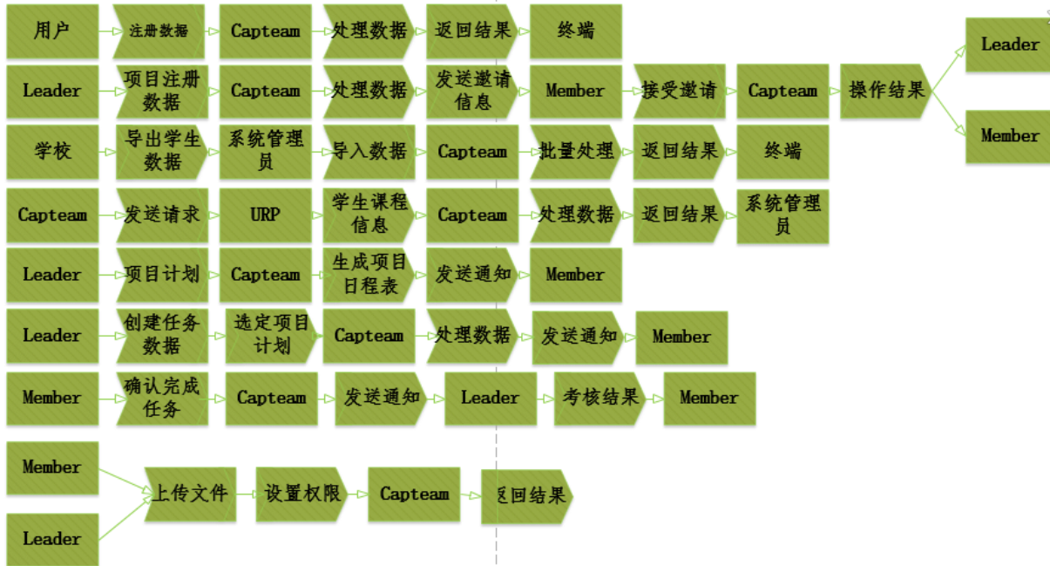

**2.5 Definition of rules**

A brief descriptions to some definition of rules of the whole system is listed below, and the specific description will be expounded in the stage of demands analysis.

|  |  |
| --- | --- |
| No. | Description of the rules |
| 1 | Normally, the system can support one hundred users at the same time, and the time for error buffering keeps in half an hour; |
| 2 | The system offers great user experience with at least 98% users are satisfied with the system; |
| 3 | The background database of the system has to be synchronously backuped once a day, in order to achieve safety redundancy for data; |
| 4 | For the sake of safety, the system will have access control; |

**2.6 业务风险**

机遇与风险并存，虽然通过前面的分析，我们发现本项目有着它特有的机遇，但是同样也存在着风险。经过讨论，我们列出了目前可能存在的风险，分别给出了风险等级及解决方案。表格见下页。

|  |  |  |  |
| --- | --- | --- | --- |
| 编号 | 描述 | 等级 | 解决方案 |
| RI-1 | 用户难以转变以前的协作模式，不易接受新平台 | 4 | 通过与高校合作，设计新颖的宣传等方式，鼓励同学们使用本平台 |
| RI-2 | 涉足不熟悉的产品领域，花费在设计和实现上的时间比预期的要多 | 2 | 在前期就考虑到这一问题，为此预留出一定的时间 |
| RI-3 | 产品部分功能或业务流程与大学生实际情况不相符，不能满足各个专业团队协作的特殊属性 | 2 | 要进行充分的前期调研，同时，在敏捷开发的过程中，不断收集用户反馈，发现问题及时修正 |
| RI-4 | 要求与其他系统或不受本项目组控制的系统相连，导致无法预料的设计、实现和测试工作 | 3 | 对于需要连接的外部系统进行充分的调研 |
| RI-5 | 过高估计了增强性工具对于项目进度的节省量 | ２ | 前期对于增强性工具进行充分调研，同时预留出部分弹性时间 |
| 编号 | **描述** | **等级** | **解决方案** |
| RI-6 | 需求定义欠佳，而进一步的定义会扩展项目范畴 | 3 | 前期定义需求时进行多次讨论、分析 |
| RI-7 | 产品定义含混的部分比预期需要更多的时间 | 4 | 尽量精确产品定义，避免产品定义含混这种情况的发生 |
| RI-8 | 得不到高校的合作支持，难以进入大学校园 | 5 | 寻求交大教师的帮助，首先在交大试用本产品。以此为基础向外校推广 |
| RI-9 | UI导航设计不明确，用户体验较差，放弃使用本产品 | 2 | 前期UI设计完成后，让部分用户试用，收集反馈意见进行进一步改进 |
| RI-10 | 前期架构设计不合理，导致系统不稳定，负载能力差，能承载的并发量小 | 4 | 在产品开发前期，要进行市场调研，结合对于本产品未来的推广方案中期望的用户数量，设计合适的产品架构 |
| RI-11 | 风险管理粗心导致未能发现重大的项目风险 | 1 | 进行多次会议、讨论，尽量使考虑更加全面 |

**3 Demands analysis and explaination**

**3.1 Functional demans**

**3.1.1** **System Use Case Model**



**3.1.2 Descriptions of System Use Case**

* **Log in**

  


|  |  |  |  |
| --- | --- | --- | --- |
| **User case name** | Log in | | System design of user case type |
| **User case ID** | SC001 | |
| **Main business participators** | Users | | |
| **Other participators** | None | | |
| **Interests of related people of the projects** | User：Wish to enter the system by username and password; | | |
| **Description** | This user case describes the related events when users log in the system; | | |
| **Precondition** | Users enter the log in interface of the system; | | |
| **Post condition** | Users enter the system as their own identity, and get their information; | | |
| **Trigger conditions** | Users enter the log in interface of the system; | | |
| **Basic flow**  **Extend process** | Action participators | System response | |
| 1. The user enter the log in interface; 2. Input his own username and password; 3. Click to log in; | The user information management system try to match the information entered by the user to the information from the database, and return the matching situation; | |
| **End** | None | | |
| **Business rules** | Users succeed in log in or fail; | | |
| **Constraints and instructions** | None | | |
| **Assumption** | If matched username and passwork are found, users will enter the correspongding user interface;  If matched username and passwork are not found, users will be noticed that fail to log in; | | |
| **Unsolved problems** | None | | |
| **User case name** | None | | |

* **Register**



|  |  |  |
| --- | --- | --- |
| **User case name** | Register | System design of user case type |
| **User case ID** | SC002 |
| **Main business participators** | Users | |
| **Other participators** | None | |
| **Interests of related people of the projects** | 用户：希望注册系统的一个新账号  User: wish to register a new | |
| **Description** | 该用例描述了用户注册时涉及的事件 | |
| **Precondition** | 无 | |
| **Post condition** | 更新数据库的用户信息 | |
| **Trigger conditions** | 用户点击注册按钮 | |
| **Basic flow**  **Extend process** | 动作参与者 | 系统响应 |
| 1. 用户点击注册 2. 输入注册信息 3. 点击提交 | 用户信息管理系统将用户输入的注册用户名与数据库中的已有用户名进行匹配，若有重复则返回提示，若无重复则更新数据库信息返回成功。 |
| **End** | 若注册名无重复，数据库及时更新用户信息表，根据输入的注册信息添加一个用户信息 | |
| **Business rules** | 用户注册成功或者注册失败 | |
| **Constraints and instructions** | 数据库信息更新结束需要反馈信息 | |
| **Assumption** | 注册用户名没有重名，则注册成功，更新数据库，并进入相应的用户界面  注册用户名重名，提示用户名已注册 | |
| **Unsolved problems** | 没有两方或两方以上的用户在同时注册且输入了相同的注册名 | |
| **User case name** | 无 | |

* **批量导入用户数据**



|  |  |  |  |
| --- | --- | --- | --- |
| **用例名** | 批量导入用户数据 | | 用例类型系统设计 |
| **用例ID** | SC003 | |
| **主要业务参与者** | 管理员，学校 | | |
| **其他参与者** | 无 | | |
| **项目相关人员兴趣** | 管理员：希望获得学校学生的学号等基础数据；学校：希望数据安全性得到保证 | | |
| **描述** | 该用例描述用户管理系统从学校获取大量学生信息时涉及的事件 | | |
| **前置条件** | 所涉及的学校与平台签订合同，获得了获取各个学生信息的权限，且实现了获取信息的接口 | | |
| **后置条件** | 更新数据库的用户信息 | | |
| **触发条件** | 平台与学校签订合同 | | |
| **基本流程** | 动作参与者 | 系统响应 | |
| 1.管理员请求批量导入用户信息  2.学校提供学生学号等基础数据 | 用户信息管理系统接收发送过来的用户信息，及时更新数据库的用户信息。 | |
| **扩展流程** | 保证数据的安全性。 | | |
| **结束** | 批量用户信息导入成功或者被拒绝获取信息时该用例结束 | | |
| **业务规则** | 用户名规范命名，统一为学校简写_学号  数据库信息更新结束需要反馈信息 | | |
| **实现约束和说明** | 批量导入了用户数据 | | |
| **假设** | 学校愿意与平台合作并提供数据 | | |
| **待解决问题** | 无 | | |

* **查看个人信息**



|  |  |  |  |
| --- | --- | --- | --- |
| **用例名** | 查看个人信息 | | 用例类型系统设计 |
| **用例ID** | SC004 | |
| **主要业务参与者** | 用户 | | |
| **其他参与者** | 无 | | |
| **项目相关人员兴趣** | 用户：希望看到自己的个人信息 | | |
| **描述** | 描述用户查看个人信息时涉及的事件 | | |
| **前置条件** | 用户已成功登录 | | |
| **后置条件** | 无 | | |
| **触发条件** | 用户点击查看个人信息 | | |
| **基本流程** | 动作参与者 | 系统响应 | |
| 请求查看个人信息 | 接收当前用户的用户名，传入数据库查询相关信息，获得信息以后返回查询结果并显示。 | |
| **扩展流程** | 无 | | |
| **结束** | 用户点击确定而离开查看个人信息界面 | | |
| **业务规则** | 只能根据当前用户的用户名进行信息的查询，不能查询其他人的信息 | | |
| **实现约束和说明** | 显示当前用户的个人信息 | | |
| **假设** | 查询信息能得到合理的响应 | | |
| **待解决问题** | 无 | | |

* **修改个人信息**





|  |  |  |  |
| --- | --- | --- | --- |
| **用例名** | 修改个人信息 | | 用例类型系统设计 |
| **用例ID** | SC005 | |
| **主要业务参与者** | 用户 | | |
| **其他参与者** | 无 | | |
| **项目相关人员兴趣** | 用户：希望修改自己的个人信息 | | |
| **描述** | 描述用户修改个人信息时涉及的事件 | | |
| **前置条件** | 用户已成功登录 | | |
| **后置条件** | 无 | | |
| **触发条件** | 用户点击修改个人信息按钮 | | |
| **基本流程** | 动作参与者 | 系统响应 | |
| 请求修改个人信息  选择修改项并进行修改  选择取消则撤销修改操作，选择保存则提交修改操作 | 判断当前用户请求是否合理，合理则接收当前用户的用户名，传入数据库查询相关信息，获得信息以后返回查询结果，显示在界面上。接受用户修改后的新信息，判断修改是否合理，不合理则返回修改界面，合理则更新数据库，并返回更新结果，显示新信息。 | |
| **扩展流程** | 无 | | |
| **结束** | 用户点击取消或修改提交后显示新的信息 | | |
| **业务规则** | 只能根据当前用户的用户名进行信息的查询，不能查询更改其他人的信息 | | |
| **实现约束和说明** | 成功修改个人信息，数据库及时更新 | | |
| **假设** | 更新信息能得到合理的响应 | | |
| **待解决问题** | 无 | | |

* **修改项目信息**



|  |  |  |
| --- | --- | --- |
| **用例名** | 修改项目信息 | 用例类型系统设计 |
| **用例ID** | SC008 |
| **主要业务参与者** | 项目发起者，MoChou平台 | |
| **其他参与者** | 无 | |
| **项目相关人员兴趣** | 平台：希望及时获取、更新及管理项目信息。  项目发起者：平台中的项目信息是准确的。 | |
| **描述** | 描述平台对项目信息的更新中涉及的事件。 | |
| **前置条件** | 团队发起者已经注册了平台的账号，并获得了修改一个项目的权限。 | |
| **后置条件** | 平台更新项目信息数据库的项目信息。 | |
| **触发条件** | 该项目信息发生变更。 | |
| **基本流程** | 动作参与者 | 系统响应 |
| 1.项目自身信息变动  2.项目更新自身信息，通知平台  3.平台更新信息 | 平台对用户身份进行判断，项目管理子系统将对将要更新的项目信息进行判断，拒绝非法请求，及时更新数据库的项目信息。 |
| **扩展流程** | 平台中的项目一旦变动，及时更新。平台可以查询项目信息。 | |
| **结束** | 信息成功更新或被拒绝通过时该用例结束。 | |
| **业务规则** | 必须拥有发起者权限才能修改项目信息；信息更新结束需要反馈信息（项目更新成功）。 | |
| **实现约束和说明** | 修改平台中的该项目信息 | |
| **假设** | 所有信息都能检测到且及时更新，更新成功的信息都是合理的。 | |
| **待解决问题** | 无 | |

* **创建/删除/修改项目**





|  |  |  |  |
| --- | --- | --- | --- |
| **用例名** | 创建新项目 | 用例类型系统设计 | |
| **用例ID** | SC006 |
| **主要业务参与者** | 项目发起者，MoChou平台 | | |
| **其他参与者** | 无 | | |
| **项目相关人员兴趣** | 平台：希望及时获取、更新及管理的项目信息 | | |
| **描述** | 项目发起者：平台中的项目信息是准确的 | | |
| **前置条件** | 该用例描述了平台对团队发起者新建项目的增加中涉及的事件 | | |
| **后置条件** | 已经注册了平台的账号 | | |
| **触发条件** | 平台增加项目信息数据库的项目信息 | | |
| **基本流程** | 动作参与者 | | 系统响应 |
| 1. 发起者登录平台用户账号。 2. 发起者以发起者身份把新项目信息交给平台。 3. 平台更新项目信息。 | | 平台对用户身份进行判断，项目管理子系统将对新的项目信息进行判断，拒绝非法请求，及时更新数据库的项目信息。 |
| **扩展流程** | 平台中的项目一旦变动，及时更新。平台可以查询项目信息。 | | |
| **结束** | 信息成功更新或被拒绝通过时该用例结束。 | | |
| **业务规则** | 信息更新结束需要反馈信息（项目已经创建成功）。 | | |
| **实现约束和说明** | 管理平台中的项目信息。 | | |
| **假设** | 所有信息都能检测到且及时更新，更新成功的信息都是合理的。 | | |
| **待解决问题** | 无 | | |

* **创建/删除/修改日志**





|  |  |  |  |
| --- | --- | --- | --- |
| **用例名** | 创建/删除/修改日志 | | 用例类型系统设计 |
| **用例ID** | SC008 | |
| **主要业务参与者** | 用户，平台 | | |
| **其他参与者** | 无 | | |
| **项目相关人员兴趣** | 平台：希望及时获取、更新及管理的日志信息  项目发起者：平台中的日志信息是准确的。 | | |
| **描述** | 该用例描述了平台对项目信息的删除中涉及的事件。 | | |
| **前置条件** | 团队发起者已经注册了平台的账号，并参与了一个项目 | | |
| **后置条件** | 平台更新数据库的日志信息。 | | |
| **触发条件** | 用户需要进行日志操作 | | |
| **基本流程** | 动作参与者 | 系统响应 | |
| 1. 用户创建/修改/删除日志信息。 2. 平台更新用户信息 | 平台对用户身份进行判断，日志子系统将对将要更改的日志信息进行判断，拒绝非法请求，及时更新数据库项目信息。 | |
| **扩展流程** | 平台中的项目一旦变动，及时更新。平台可以查询项目信息。 | | |
| **结束** | 成功更新或被拒绝通过时该用例结束 | | |
| **业务规则** | 只有该项目的发起者才能删除日志；信息更新结束需要反馈信息（日志更新成功） | | |
| **实现约束和说明** | 更新平台中的相应日志信息 | | |
| **假设** | 所有信息都能检测到且及时更新，更新成功的信息都是合理的。 | | |
| **待解决问题** | 无 | | |

* **参与项目**



|  |  |  |  |
| --- | --- | --- | --- |
| **用例名** | 参与项目 | | 用例类型系统设计 |
| **用例ID** | SC009 | |
| **主要业务参与者** | 项目合作者，MoChou平台 | | |
| **其他参与者** | 项目发起者 | | |
| **项目相关人员兴趣** | 平台：希望及时获取、更新及管理项目信息。  项目发起者：平台中的项目及成员信息准确  项目普通成员：平台中的项目信息是准确的。 | | |
| **描述** | 该用例描述了平台中项目参与者对参与项目涉及的事件。 | | |
| **前置条件** | 该成员已经注册了平台的账号 | | |
| **后置条件** | 平台实现项目成员信息数据库的更新。 | | |
| **触发条件** | 平台的用户以参与者身份请求参与该项目 | | |
| **基本流程** | 动作参与者 | 系统响应 | |
| 1. 该成员登录平台用户账号 2. 该成员以参与者身份请求参与项目 3. 平台更新成员信息 4. 平台通知项目发起者 | Capteam平台对用户身份进行判断，项目管理子系统将对将要更爱项目成员信息进行判断，拒绝非法请求，及时更新数据库的项目信息。并通知项目发起者 | |
| **扩展流程** | 平台中的项目成员信息一旦变动，及时更新。团队发起者可以查看所有的成员信息。 | | |
| **结束** | 成员信息成功更新或被拒绝通过时该用例结束 | | |
| **业务规则** | 需要反馈信息（请求已经发送成功） | | |
| **实现约束和说明** | 项目参与者发送请求，该项目成员信息更改。 | | |
| **假设** | 所有信息都能检测到且及时更新，更新成功的信息都是合理的。 | | |
| **待解决问题** | 无 | | |

* **项目考核**





|  |  |  |  |
| --- | --- | --- | --- |
| **用例名** | 项目考核 | | 用例类型系统设计 |
| **用例ID** | SC010 | |
| **主要业务参与者** | 项目发起者，MoChou | | |
| **其他参与者** | 用户合作者 | | |
| **项目相关人员兴趣** | 项目发起者：希望评定项目成员的完成情况  项目合作者：希望收到评定结果 | | |
| **描述** | 该用例描述项目发起者对项目成员进行完成任务评定时涉及的事件 | | |
| **前置条件** | 用户已成功登录，该用户是该项目发起者 | | |
| **后置条件** | 更新数据库中的考核信息 | | |
| **触发条件** | 用户点击完成情况评定 | | |
| **基本流程** | 动作参与者 | 系统响应 | |
| 请求完成情况评定;评定每个项目成员的任务质量;选择取消则撤销修改操作，选择保存则提交设定操作。 | 判断当前用户请求是否合理，合理则接收选定的项目成员和任务质量评定信息，判断是否合理，合理计算评定总结果，接收当前任务编号和评定信息，传入数据库更新相关信息，且返回更新结果，显示在界面上；更新成功后，发送消息推送给相关项目成员，显示该项目组成员的评定信息。 | |
| **扩展流程** | 发送消息推送给相关项目成员显示该项目组成员的评定信息 | | |
| **结束** | 用户点击取消或消息推送完成 | | |
| **业务规则** | 必须是一个项目的发起者才能进行评定;质量评定的满分为一百分。 | | |
| **实现约束和说明** | 成功修改考核信息，数据库及时更新，组员收到消息提醒 | | |
| **假设** | 查询的信息能得到合理响应，成员能及时收到消息 | | |
| **待解决问题** | 无 | | |

* **谢绝/同意成员**



|  |  |  |  |
| --- | --- | --- | --- |
| **用例名** | 谢绝/同意成员 | | 用例类型系统设计 |
| **用例ID** | SC011 | |
| **主要业务参与者** | 项目发起者，MoChou | | |
| **其他参与者** | 用户合作者 | | |
| **项目相关人员兴趣** | 项目发起者：希望谢绝/同意用户参与的请求  项目合作者：希望收到结果 | | |
| **描述** | 该用例描述项目发起者谢绝/同意成员时涉及的事件 | | |
| **前置条件** | 用户已成功登录，该用户是该项目发起者 | | |
| **后置条件** | 更新数据库中的考核信息 | | |
| **触发条件** | 用户点击完成谢绝 | | |
| **基本流程** | 动作参与者 | 系统响应 | |
| 请求谢绝/同意;数据库更新；通知相应用户 | 系统接收到谢绝/同意请求，更新数据库成功后，发送消息推送给相应合作者 | |
| **扩展流程** | 发送消息推送给相关用户 | | |
| **结束** | 用户点击取消或消息推送完成 | | |
| **业务规则** | 必须是一个项目的发起者才能进行操作 | | |
| **实现约束和说明** | 成功操作后，数据库及时更新，组员收到消息提醒 | | |
| **假设** | 查询的信息能得到合理响应，成员能及时收到消息 | | |
| **待解决问题** | 无 | | |

**3.2 非功能性需求**

**3.2.1 用户界面需求**

|  |  |  |
| --- | --- | --- |
| **编号** | **名称** | **项** |
| 1 | 数据转化 | 将数据转换成图表、图形进行可视化展示、分析，界面友好，效果炫丽 |
| 2 | 多终端 | 支持在移动终端设备上进行数据可视化； |

**3.2.2 产品质量需求**

➢ **Functionality**

|  |  |  |
| --- | --- | --- |
| **编号** | **名称** | **项** |
| 1 | 准确性 | 系统各功能运行结果与预期一致，操作可回退。 |
| 2 | 安全性 | 系统能够自动判断用户权限，不同的用户拥有不同的权限 |
| 3 | 互操作性 | 可在任何有网页的机器上操作，可在不同区域不同省份进行操作。 |
| 4 | 互操作性 | 适用于各种计算机系统及移动终端，方便操作。 |
| 5 | 依从性 | 系统通过网关与用户建立连接，同一个用户只能占用同一个网关，一个网关可与最多十个用户连接。 |
| 6 | 依从性 | 系统网关受限于请求吞吐量，每秒不多于100个用户请求。 |
| 7 | 依从性 | 其他业务规则已在用例中详细说明。 |
| 8 | 安全性 | 系统从教务处获取学生课表的时候系统能够检测数据的安全性问题 |
| 9 | 安全性 | 在受到病毒攻击时，系统应该能够检测到攻击操作并立刻停止服务器运行。 |
| 10 | 安全性 | 应用程序必须扫描所有进入的或更改的数据及软件，以发现所有被公布的知名计算机病毒、蠕虫及特洛伊木马。 |
| 11 | 安全性 | 当受到黑客入侵时，系统应该能够检测到伪造数据的更改。 |
| 12 | 安全性 | 至少99.9%以上的时间，系统能够保护用户之间传递的消息不被非授权增加、修改、删除。 |

➢ **Reliability**

|  |  |  |  |
| --- | --- | --- | --- |
| **编号** | **名称** | **项** | **值** |
| 1 | 成熟性 | 在任意时刻服务器正常运行的可能性 | 99.99% |
| 2 | 成熟性 | 服务器平均正常运行时间 | 200天 |
| 3 | 成熟性 | 服务器平均故障恢复时间 | 1小时 |
| 4 | 易恢复性 | 系统可以进行数据备份，最近30日的业务数据、数据库数据全备份（30份、每日1份、保留2个月），每周周五进行数据完全备份一次（保留2个月），每月末最后一日进行数据完全备份一次（保留1年），每1小时业务数据、数据库数据增量备份一次 |  |
| 5 | 易恢复性 | 重大故障需要在4-8小时内恢复数据可用性，并在5-10小时内恢复历史数据 |  |

➢ **Usability**

|  |  |  |  |
| --- | --- | --- | --- |
| **编号** | **名称** | **项** | **值** |
| 1 | 易理解性 | 专业人员理解Capteam平台所需时间 | 1天 |
| 2 | 易理解性 | 有软件基础的人员理解Capteam平台所需时间 | 1周 |
| 3 | 易理解性 | 无软件基础的人员理解Capteam平台所需时间 | 2周 |
| 4 | 易学习性 | 专业人员学习使用Capteam平台所需时间 | 1小时 |
| 5 | 易学习性 | 有软件基础的人员学习使用Capteam平台所需时间 | 2小时 |
| 6 | 易学习性 | 无软件基础的人员学习使用Capteam平台所需时间 | 3小时 |
| 7 | 易操作性 | Leader、Member操作熟练时间 | 1小时 |

➢ **Efficiency**

|  |  |  |  |  |  |  |
| --- | --- | --- | --- | --- | --- | --- |
| **编号** | **名称** | **项** | | | **值** | |
| 1 | 吞吐量 | 顾客进行操作的频率 | | | 每天三个高峰时间段 | |
| 2 | 容量 | 系统用户数 | | | <=1,000,000 | |
| 3 | 容量 | 同时在线用户数 | | | <=1,000 | |
| 4 | 容量 | 交通信息 | | | <=10,000,000 | |
| 5 | 容量 | 交易记录 | | | <=1,000,000 | |
| 6 | 容量 | 信誉保障 | | | <=1,000,000 | |
| 编号 | 名称 | 项 | 响应时间 | 抖动 | | 优先级 |
| 1 | 延迟 | 点击 | <2秒 | <1秒 | | 高 |
| 2 | 延迟 | 提交 | <5秒 | <2秒 | | 中 |
| 3 | 延迟 | 通知 | <10秒 | <3秒 | | 高 |

* **Portability**

|  |  |  |
| --- | --- | --- |
| **编号** | **名称** | **项** |
| 1 | 适应性 | 装有浏览器的电子设备，包括PC及终端设备 |
| 2 | 易安装性 | 装有浏览器的电子设备，包括PC及终端设备 |

* **Maintainability**

|  |  |  |
| --- | --- | --- |
| **编号** | **名称** | **项** |
| 1 | 易分析性 | 分析平台故障的平均工作量小于1人/天 |
| 2 | 易分析性 | 分析平台瘫痪或由于频繁的繁琐操作导致系统故障问题小于1人/周 |
| 3 | 易分析性 | 分析升级添加新功能需要更改的模块时间小于1人/周 |
| 4 | 易改变性 | 修复问题（包括回归测试、文档更新）的平均工作量小于1人/周 |
| 5 | 易改变性 | 完成一次小版本升级的平均工作量小于1人/周 |
| 6 | 易改变性 | 完成一次重大版本升级平均工作量小于1人/月 |
| 7 | 易改变性 | 完成一次数据恢复的平均工作量小于1人/天 |
| 8 | 稳定性 | 系统可添加新的功能，改进已有的功能或修复系统中的缺陷 |
| 9 | 稳定性 | 系统可删除不再想要的功能，即优化或简化现有平台的系统功能。 |

**4 概要设计**

**4.1 总体设计**

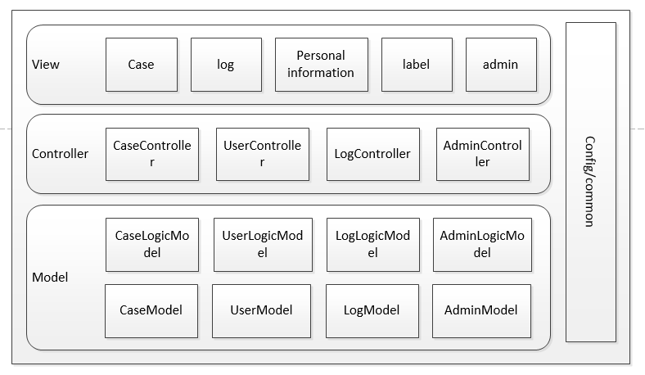

 展现层

展现层是该平台直接面向用户的界面，直接与用户互动，它的主要作用是提供给用户各种操作界面，各种操作方案，捕获用户的输入，通过表现层将这些用户输入的信息捕获并收集，以便交由到服务器进行处理，从而将其反馈给前台。用户将通过表现层的各个功能群组中的功能模块进行操作。前端表现层会将收到的请求以及各项数据收集起来，传递给应用层，进行相应的处理。

 业务逻辑层

业务逻辑层的主要任务是根据实际的业务规则，实现相应的业务逻辑功能。在这一层中，主要描述表现层所涉及到的目标服务进行对应的实现。在此业务逻辑层主要实现对应表现层的功能模块。

 数据层

数据库管理层主要职责是管理数据库之间的各种连接、断开等，并对数据库的各种操作中出现的一些异常进行记录和给出一些提示，以方便开发人员在需要的时候，对数据库相关的功能进行测试或者调试。一个系统中的所有功能，都涉及到各种各样的信息配置、业务处理数据、系统运行效果状态等，数据库对这些数据信息可以进行归档，提供一些基本的查询接口，以保证数据的可靠性和完整性。

**4.2 部署架构**

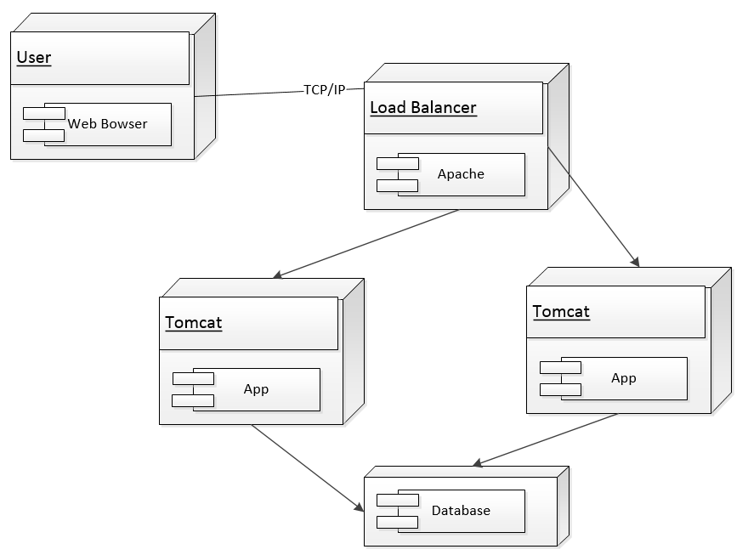

**4.3 功能模块结构**

根据前面的分析，本系统划分为五大模块：个人管理、项目管理、成员管理、日志和推荐。他们各自负责自己的业务逻辑的实现与数据的处理分析，各个模块之间的通信依赖于接口。



**4.3.1 个人管理模块**

个人管理模块主要负责管理用户的个人信息，包括登陆注册、批量导入用户、个人信息管理等功能的处理与维护。它的整体框架图下图所示：



**4.3.2 项目管理模块**



**4.3.3 日志**



**4.3.4 推荐**



**4.3.5 成员管理模块**



**4.4 关键技术介绍**

**5 详细设计**

**5.1 包设设计**

**5.2 模块设计**

**5.2.1 个人模块设计**

**5.2.2 项目模块设计**

**5.2.3 成员模块设计**

**5.2.4 推荐模块设计**

**5.2.5 日志模块设计**

**5.3 关键类说明**

**5.3.1 sfsfsdfsdf**

**6 数据建模**

**6.1 概念模型**

**6.2 逻辑模型**

**6.3 物理模型**

**6.4 sdsdsd**

**7 架构设计**

**7.1 架构风格**



作为一个web项目，为了工作的高效性，我们采用ThinkPHP框架。该框架是基于MVC的架构设计。主要考虑的质量属性如下：

**可维护性：**作为web系统，前端界面的修改十分常见，但是后台逻辑处理等相对改动并没有很大。采用MVC的设计，view层的设计十分独立与控制器层无关系。同时项目的这种分层设计也利于程序员看懂代码，易于修改。

**可扩展性：**作为一个web系统，不仅在PC可以访问，后期计划可能在手机端也是可以访问的。但是由于用户习惯问题，手机端跟PC端访问的界面不一定是同一界面，但是他们对应的控制器相同。由于采用了MVC的设计，增加这样一个前端界面，对系统其它部分并无影响。

**可重用性：**以模型层为例，在该项目中，model层是映射的数据库及其操作类。不同的控制器可能对同一数据进行访问，将该部分与控制器层分开使得该部分的代码可重用性得到提高。

**7.2 设计模式的应用与实现**

**7.2.1 状态模式**

**环境类(Context)：**包含changeState（String State）方法用于设置当前状态。

**抽象状态类(ICase)：**定义一个抽象类用于封装对应Context的状态的行为。

**具体状态类(PrepareCase,CurrentCase,DoneCase)：**每一个子类对应一个状态实现抽象类中的方法。

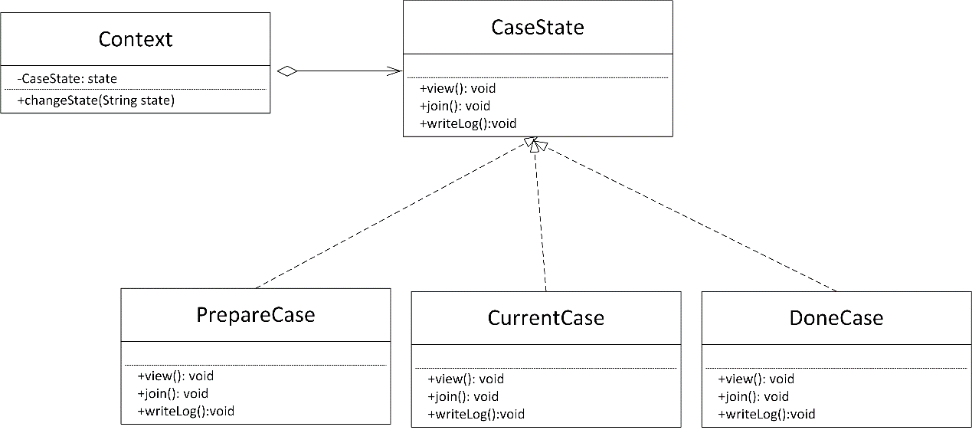

**7.2.2 工厂模式和单例模式结合模式**

我们使用了一个EmailFactory的单实例工厂，然后根据传入的参数不同，EmailFactory会生产出不同的PlainEmail类与HtmlEmail类。类图如下：

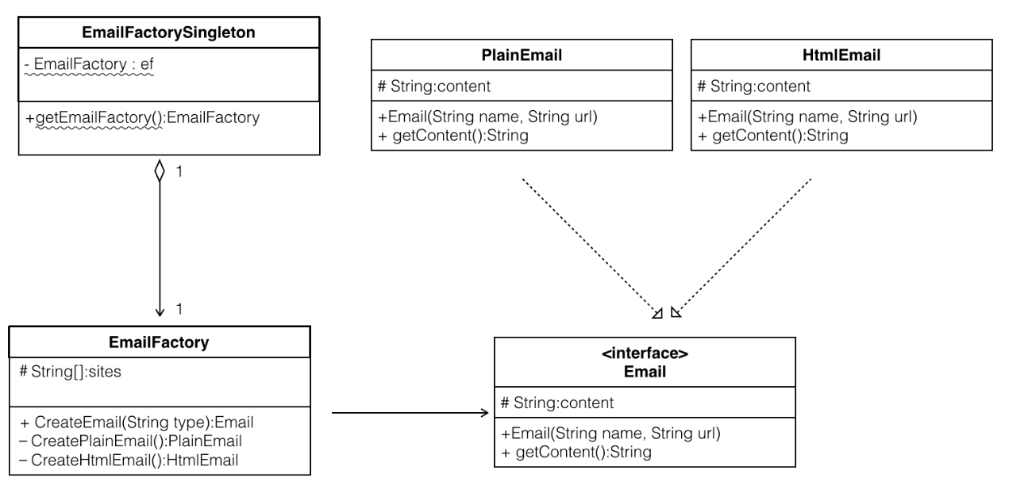

**7.2.3 策略模式**

InputText是需要验证的内容。Validator是所有基于field的验证规则的父类，它定义了doValidation方法，每个子类代表了一种field的验证策略，而子类又实现了自身策略的具体验证规则方法，在doValidation方法中被调用。

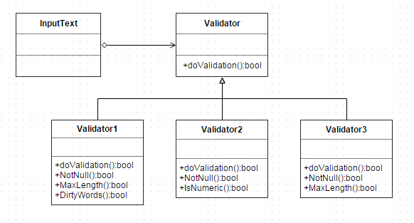

**7.2.4 组合模式**

采用了组合模式，ValidationField即Component类，是一个接口，定义了验证方法doValidation，组件添加方法addValidationField，组件剔除方法removeValidationField，获得组合中的实例方法getChild。FormValidation类实现了ValidationField接口，不同的FormValidation实现代表了对不同field的验证，如密码框的验证、项目名的验证等等，不同的表单需要验证不同field，FormValidation类代表表单，根据不同表单的需要添加不同的field验证。

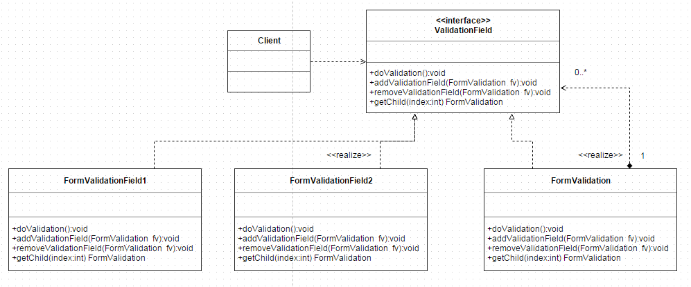

**7.2.5 观察者模式**

Broadcast类负责通知项目相关者状态变化，类中包含了AddUser和DeleteUser两个方法来绑定和解绑相关用户，在Broadcast中维护一个用户列表，代表与项目相关者。当项目状态发生变化时，调用Nodify方法，通知项目相关者。

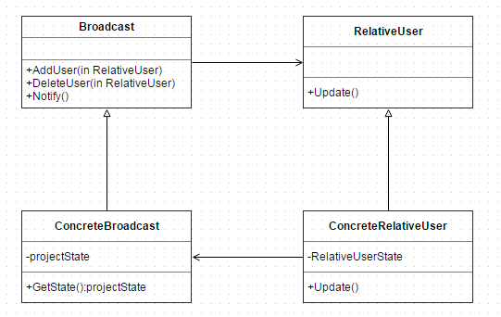

**7.2.6 备忘录模式**

在Javascript中维护全局变量，保留在页面中，当页面刷新时，若没有对变量值进行更新，则采用原来的变量值，节省了再次向服务器发起请求获取数值的操作。

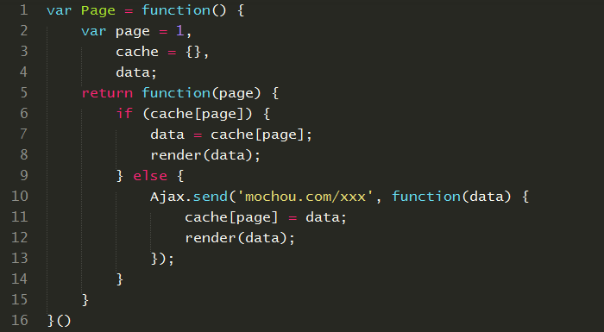

**7.2.7采用设计模式的优点**

**7.2.7.1状态模式**

* 状态模式将与特定状态相关的行为局部化，并且将不同状态的行为分割开来。
* 所有状态相关的代码都存在于某个ConcereteState中，所以通过定义新的子类很容易地增加新的状态和转换。
* 状态模式通过把各种状态转移逻辑分不到State的子类之间，来减少相互间的依赖。

**7.2.7.2单例与工厂模式**

* 防止在应用程序中实例化多个对象。这就节约了开销，每个实例都要占用一定的内存，创建对象时需要时间和空间。
* 工厂方法去除了条件分支（解除了工厂类与分支的耦合），解决了简单工厂对修改开放的问题。

**7.2.7.3策略模式**

* 策略模式是一种定义一系列算法的方法，从概念上来看，所有算法完成的都是相同的工作，只是实现不同，它可以以相同的方式调用所有的算法，减少了各种算法类与使用算法类之间的耦合。
* 策略模式的Stratege类为Context定义了一系列的可供重用的算法或行为。继承有助于析取出这些算法的公共功能。
* 策略模式每个算法都有自己的类，可以通过自己的接口单独测试。因而简化了单元测试。
* 策略模式将具体算法或行为封装到Stratege类中，可以在使用这些类中消除条件分支（避免了不同行为堆砌到一个类中）。

**7.2.7.4组合模式**

* 使客户端调用简单，它可以一致使用组合结构或是其中单个对象，简化了客户端代码。
* 容易在组合体内增加对象部件。客户端不必因加入了新的部件而更改代码。有利于功能的扩展。

**7.2.7.5观察者模式**

* 观察者模式解除了主题和具体观察者的耦合，让耦合的双方都依赖于抽象，而不是依赖具体。从而使得各自的变化都不会影响另一边的变化。

**7.2.7.6备忘录模式**

* 当发起人角色中的状态改变时，有可能这是个错误的改变，我们使用备忘录模式就可以把这个错误的改变还原。
* 备份的状态是保存在发起人角色之外的，这样，发起人角色就不需要对各个备份的状态进行管理。

**8 接口设计**

**8.1 GUI布局设计**



**8.2 GUI导航设计**



**9 运行设计**

**9.1 运行模块组合**

用户在浏览器输入网址后便进入平台，首先需要登陆、注册才能进行其他操作。通过各模块之间的调用，读入并对输入处理后存储。接收到返回信息后对数据进行处理从而显示出来。

服务端程序必须始终处于活动状态。接收到数据后，调用数据处理/查询模块对数据库进行访问，完成后将信息返回客户端。

**9.2 运行控制**

运行控制将严格按照各模块间函数调用关系来实现。在各事务中心模块中，需对运行控制进行正确的判断，选择正确的运行控制路径。

在网络传输方面，客户端在发送数据后，将等待服务器的确认收到信号，收到后，再次等待服务器发送回答数据，然后对数据进行确认.服务器在接到数据后发送确认信号，在对数据处理，访问数据库后，将返回信息送回客户端，并等待确认。

**9.3 运行时间**

在需求分析中，对运行时间的要求为必须对做出的操作有较快的反应。网络硬件对运行时间有最大的影响，当网络负载量大时，对操作反应将受到很大的影响。其次是服务器的性能，这将影响对数据库访问时间即操作时间的长短，影响加大客户机操作的等待时间，所以必须使用高性能的服务器。

**10 输入输出设计**

**10.1 输入设计**

|  |  |  |  |  |
| --- | --- | --- | --- | --- |
| **注册信息输入** | | | | |
| **输入项目名称** | **约束条件** | **相关GUI** | **输入媒介** | **输入方式** |
| 帐户名 | 唯一，0—30个字符 | 文本框 | 键盘 | 实时输入 |
| 密码 | 0—20个字符 | 文本框 | 键盘 | 实时输入 |
| 确认密码 | 0—20个字符 | 文本框 | 键盘 | 实时输入 |
| 邮箱 | 0—50个字符 | 文本框 | 键盘 | 实时输入 |
| 所在学校 | 从列表选择 | 下拉框 | 鼠标 | 实时输入 |
| 学号 | 0—20个字符 | 文本框 | 键盘 | 实时输入 |
| 姓名 | 0—50个字符 | 文本框 | 键盘 | 实时输入 |
| 确认 |  | 按钮 | 鼠标 | 实时输入 |

|  |  |  |  |  |
| --- | --- | --- | --- | --- |
| **登陆信息输入** | | | | |
| **输入项目名称** | **约束条件** | **相关GUI** | **输入媒介** | **输入方式** |
| 帐户名 | 唯一，0—30个字符 | 文本框 | 键盘 | 实时输入 |
| 密码 | 0—20个字符 | 文本框 | 键盘 | 实时输入 |
| 验证码 | 4个字符 | 文本框 | 键盘 | 实时输入 |
| 确认 |  | 按钮 | 鼠标 | 实时输入 |

|  |  |  |  |  |
| --- | --- | --- | --- | --- |
| **批量导入用户输入** | | | | |
| **输入项目名称** | **约束条件** | **相关GUI** | **输入媒介** | **输入方式** |
| 导入文件 | Excel表格，格式必须按照系统要求 | 文本选择框 | 鼠标 | 实时输入 |
| 确认 |  | 按钮 | 鼠标 | 实时输入 |

|  |  |  |  |  |
| --- | --- | --- | --- | --- |
| **个人信息修改输入** | | | | |
| **输入项目名称** | **约束条件** | **相关GUI** | **输入媒介** | **输入方式** |
| 原密码 | 0—20个字符 | 文本框 | 键盘 | 实时输入 |
| 新密码 | 0—20个字符 | 文本框 | 键盘 | 实时输入 |
| 确认密码 | 0—20个字符 | 文本框 | 键盘 | 实时输入 |
| 验证码 | 4个字符 | 文本框 | 键盘 | 实时输入 |
| 确认 |  | 按钮 | 鼠标 | 实时输入 |

|  |  |  |  |  |
| --- | --- | --- | --- | --- |
| **删除项目信息输入** | | | | |
| **输入项目名称** | **约束条件** | **相关GUI** | **输入媒介** | **输入方式** |
| 选择要删除的项目名 | 从列表中选择需要删除的项 | 勾选框 | 鼠标 | 实时输入 |
| 确认 |  | 按钮 | 鼠标 | 实时输入 |

|  |  |  |  |  |
| --- | --- | --- | --- | --- |
| **创建项目信息输入** | | | | |
| **输入项目名称** | **约束条件** | **相关GUI** | **输入媒介** | **输入方式** |
| 项目名 | 唯一，0—100个字符 | 文本框 | 键盘 | 实时输入 |
| 项目内容 | 文本 | 文本框 | 键盘 | 实时输入 |
| 项目起始时间 | 具体年月日 | 日期选择框 | 鼠标 | 实时输入 |
| 项目结束时间 | 具体年月日 | 日期选择框 | 鼠标 | 实时输入 |
| 项目组成员在Capteam平台的账户名 | 输入用户名或关键词 | 文本输入框 | 键盘 | 实时输入 |
| 搜索 |  | 按钮 | 鼠标 | 实时输入 |
| 选择项目组成员 | 根据输入的字符匹配出的用户名显示在这里，Leader从中选择组员 | List列表 | 鼠标 | 实时输入 |
| 取消已选中的组员 | 已选择的组员显示在这个list列表里，Leader从中选择不需要加入本项目组的组员 | List列表 | 鼠标 | 实时输入 |
| 删除组员 |  | 按钮 | 鼠标 | 实时输入 |
| 确认 |  | 按钮 | 鼠标 | 实时输入 |

|  |  |  |  |  |
| --- | --- | --- | --- | --- |
| **修改项目信息输入** | | | | |
| **输入项目名称** | **约束条件** | **相关GUI** | **输入媒介** | **输入方式** |
| 项目内容 | 文本 | 文本框 | 键盘 | 实时输入 |
| 项目起始时间 | 具体年月日 | 日期选择框 | 鼠标 | 实时输入 |
| 项目结束时间 | 具体年月日 | 日期选择框 | 鼠标 | 实时输入 |
| 项目组成员在Capteam平台的账户名 | 输入用户名或关键词 | 文本输入框 | 键盘 | 实时输入 |
| 搜索 |  | 按钮 | 鼠标 | 实时输入 |
| 选择项目组成员 | 根据输入的字符匹配出的用户名显示在这里，Leader从中选择组员 | List列表 | 鼠标 | 实时输入 |
| 取消已选中的组员 | 已选择的组员显示在这个list列表里，Leader从中选择不需要加入本项目组的组员 | List列表 | 鼠标 | 实时输入 |
| 删除组员 |  | 按钮 | 鼠标 | 实时输入 |
| 确认 |  | 按钮 | 鼠标 | 实时输入 |

|  |  |  |  |  |
| --- | --- | --- | --- | --- |
| **制定项目计划输入** | | | | |
| **输入项目名称** | **约束条件** | **相关GUI** | **输入媒介** | **输入方式** |
| 计划名 | 0—100个字符 | 文本框 | 键盘 | 实时输入 |
| 计划内容 | 文本 | 文本框 | 键盘 | 实时输入 |
| 计划起始时间 | 具体年月日 | 日期选择框 | 鼠标 | 实时输入 |
| 计划结束时间 | 具体年月日 | 日期选择框 | 鼠标 | 实时输入 |
| 确认 |  | 按钮 | 鼠标 | 实时输入 |

|  |  |  |  |  |
| --- | --- | --- | --- | --- |
| **修改项目计划输入** | | | | |
| **输入项目名称** | **约束条件** | **相关GUI** | **输入媒介** | **输入方式** |
| 计划名 | 0—100个字符 | 文本框 | 键盘 | 实时输入 |
| 计划内容 | 文本 | 文本框 | 键盘 | 实时输入 |
| 计划起始时间 | 具体年月日 | 日期选择框 | 鼠标 | 实时输入 |
| 计划结束时间 | 具体年月日 | 日期选择框 | 鼠标 | 实时输入 |
| 确认 |  | 按钮 | 鼠标 | 实时输入 |

|  |  |  |  |  |
| --- | --- | --- | --- | --- |
| **删除项目计划输入** | | | | |
| **输入项目名称** | **约束条件** | **相关GUI** | **输入媒介** | **输入方式** |
| 选择要删除的计划名 | 从列表中选择需要删除的项 | 勾选框 | 鼠标 | 实时输入 |
| 确认 |  | 按钮 | 鼠标 | 实时输入 |

|  |  |  |  |  |
| --- | --- | --- | --- | --- |
| **修改其他资源输入** | | | | |
| **输入项目名称** | **约束条件** | **相关GUI** | **输入媒介** | **输入方式** |
| 资源名称 | 0—100个字符 | 文本框 | 键盘 | 实时输入 |
| 负责人 | 从组员列表中选择 | 列表选择框 | 鼠标 | 实时输入 |
| 确认 |  | 按钮 | 鼠标 | 实时输入 |

|  |  |  |  |  |
| --- | --- | --- | --- | --- |
| **添加其他资源输入** | | | | |
| **输入项目名称** | **约束条件** | **相关GUI** | **输入媒介** | **输入方式** |
| 资源名称 | 0—100个字符 | 文本框 | 键盘 | 实时输入 |
| 负责人 | 从组员列表中选择 | 列表选择框 | 鼠标 | 实时输入 |
| 确认 |  | 按钮 | 鼠标 | 实时输入 |

|  |  |  |  |  |
| --- | --- | --- | --- | --- |
| **修改项目组成员信息输入** | | | | |
| **输入项目名称** | **约束条件** | **相关GUI** | **输入媒介** | **输入方式** |
| 项目名 | 从现有项目中选择 | 选择框 | 鼠标 | 实时输入 |
| 项目组成员在Capteam平台的账户名 | 输入用户名或关键词 | 文本输入框 | 键盘 | 实时输入 |
| 搜索 |  | 按钮 | 鼠标 | 实时输入 |
| 选择项目组成员 | 根据输入的字符匹配出的用户名显示在这里，Leader从中选择组员 | List列表 | 鼠标 | 实时输入 |
| 取消已选中的组员 | 已选择的组员显示在这个list列表里，Leader从中选择不需要加入本项目组的组员 | List列表 | 鼠标 | 实时输入 |
| 删除组员 |  | 按钮 | 鼠标 | 实时输入 |
| 确认 |  | 按钮 | 鼠标 | 实时输入 |

|  |  |  |  |  |
| --- | --- | --- | --- | --- |
| **删除其他资源输入** | | | | |
| **输入项目名称** | **约束条件** | **相关GUI** | **输入媒介** | **输入方式** |
| 选择要删除的资源 | 从资源列表中选择要删除的资源 | 勾选框 | 鼠标 | 实时输入 |
| 确认 |  | 按钮 | 鼠标 | 实时输入 |

|  |  |  |  |  |
| --- | --- | --- | --- | --- |
| **增加个人日程输入** | | | | |
| **输入项目名称** | **约束条件** | **相关GUI** | **输入媒介** | **输入方式** |
| 日程内容 | 文本 | 文本框 | 键盘 | 实时输入 |
| 日程开始时间 | 具体年月日 | 日期选择框 | 鼠标 | 实时输入 |
| 日程结束时间 | 具体年月日 | 日期选择框 | 鼠标 | 实时输入 |
| 确认 |  | 按钮 | 鼠标 | 实时输入 |

|  |  |  |  |  |
| --- | --- | --- | --- | --- |
| **修改个人日程输入** | | | | |
| **输入项目名称** | **约束条件** | **相关GUI** | **输入媒介** | **输入方式** |
| 日程内容 | 修改已有的日程内容 | 文本框 | 键盘 | 实时输入 |
| 日程开始时间 | 具体年月日 | 日期选择框 | 鼠标 | 实时输入 |
| 日程结束时间 | 具体年月日 | 日期选择框 | 鼠标 | 实时输入 |
| 确认 |  | 按钮 | 鼠标 | 实时输入 |

|  |  |  |  |  |
| --- | --- | --- | --- | --- |
| **删除个人日程输入** | | | | |
| **输入项目名称** | **约束条件** | **相关GUI** | **输入媒介** | **输入方式** |
| 日程内容 | 从列表中选择需要删除的项 | 勾选框 | 鼠标 | 实时输入 |
| 确认 |  | 按钮 | 鼠标 | 实时输入 |

|  |  |  |  |  |
| --- | --- | --- | --- | --- |
| **增加任务输入** | | | | |
| **输入项目名称** | **约束条件** | **相关GUI** | **输入媒介** | **输入方式** |
| 任务标题 | 文本 | 文本框 | 键盘 | 实时输入 |
| 任务内容 | 文本 | 文本框 | 键盘 | 实时输入 |
| 所属项目计划阶段 | 从下拉框中选择 | 下拉框 | 鼠标 | 实时输入 |
| 任务开始时间 | 具体年月日 | 日期选择框 | 鼠标 | 实时输入 |
| 任务结束时间 | 具体年月日 | 日期选择框 | 鼠标 | 实时输入 |
| 完成人员 | 从勾选框中勾选 | 勾选框 | 鼠标 | 实时输入 |
| 确认 |  | 按钮 | 鼠标 | 实时输入 |

|  |  |  |  |  |
| --- | --- | --- | --- | --- |
| **修改任务输入** | | | | |
| **输入项目名称** | **约束条件** | **相关GUI** | **输入媒介** | **输入方式** |
| 任务标题 | 文本 | 文本框 | 键盘 | 实时输入 |
| 任务内容 | 修改已有的日程内容 | 文本框 | 键盘 | 实时输入 |
| 所属项目计划阶段 | 从下拉框中选择 | 下拉框 | 鼠标 | 实时输入 |
| 任务开始时间 | 具体年月日 | 日期选择框 | 鼠标 | 实时输入 |
| 任务结束时间 | 具体年月日 | 日期选择框 | 鼠标 | 实时输入 |
| 确认 |  | 按钮 | 鼠标 | 实时输入 |

|  |  |  |  |  |
| --- | --- | --- | --- | --- |
| **删除个人日程输入** | | | | |
| **输入项目名称** | **约束条件** | **相关GUI** | **输入媒介** | **输入方式** |
| 任务标题 | 从列表中选择需要删除的项 | 勾选框 | 鼠标 | 实时输入 |
| 确认 |  | 按钮 | 鼠标 | 实时输入 |

|  |  |  |  |  |
| --- | --- | --- | --- | --- |
| **批量导入课程信息输入** | | | | |
| **输入项目名称** | **约束条件** | **相关GUI** | **输入媒介** | **输入方式** |
| 导入课程 |  | 按钮 | 鼠标 | 实时输入 |

|  |  |  |  |  |
| --- | --- | --- | --- | --- |
| **添加课程输入** | | | | |
| **输入项目名称** | **约束条件** | **相关GUI** | **输入媒介** | **输入方式** |
| 课程名称 | 文本 | 文本框 | 键盘 | 实时输入 |
| 教师姓名 | 文本 | 文本框 | 键盘 | 实时输入 |
| 课程时间 | 年月日及星期几都为下拉框 | 下拉框 | 鼠标 | 实时输入 |
| 课程开始时间 | 具体年月日 | 日期选择框 | 鼠标 | 实时输入 |
| 课程结束时间 | 具体年月日 | 日期选择框 | 鼠标 | 实时输入 |
| 课程教室 | 文本 | 文本框 | 键盘 | 实时输入 |
| 确认 |  | 按钮 | 鼠标 | 实时输入 |

|  |  |  |  |  |
| --- | --- | --- | --- | --- |
| **添加课程输入** | | | | |
| **输入项目名称** | **约束条件** | **相关GUI** | **输入媒介** | **输入方式** |
| 课程名称 | 文本 | 文本框 | 键盘 | 实时输入 |
| 教师姓名 | 文本 | 文本框 | 键盘 | 实时输入 |
| 课程时间 | 年月日及星期几都为下拉框 | 下拉框 | 鼠标 | 实时输入 |
| 课程开始时间 | 具体年月日 | 日期选择框 | 鼠标 | 实时输入 |
| 课程结束时间 | 具体年月日 | 日期选择框 | 鼠标 | 实时输入 |
| 课程教室 | 文本 | 文本框 | 键盘 | 实时输入 |
| 确认 |  | 按钮 | 鼠标 | 实时输入 |

|  |  |  |  |  |
| --- | --- | --- | --- | --- |
| **删除课程输入** | | | | |
| **输入项目名称** | **约束条件** | **相关GUI** | **输入媒介** | **输入方式** |
| 课程名称 | 从列表中勾选要删除的课程 | 勾选框 | 鼠标 | 实时输入 |
| 确认 |  | 按钮 | 鼠标 | 实时输入 |

|  |  |  |  |  |
| --- | --- | --- | --- | --- |
| **开启视频会议输入** | | | | |
| **输入项目名称** | **约束条件** | **相关GUI** | **输入媒介** | **输入方式** |
| 开启视频会议 |  | 按钮 | 鼠标 | 实时输入 |

|  |  |  |  |  |
| --- | --- | --- | --- | --- |
| **关闭视频会议输入** | | | | |
| **输入项目名称** | **约束条件** | **相关GUI** | **输入媒介** | **输入方式** |
| 关闭视频会议 |  | 按钮 | 鼠标 | 实时输入 |

|  |  |  |  |  |
| --- | --- | --- | --- | --- |
| **视频存档输入** | | | | |
| **输入项目名称** | **约束条件** | **相关GUI** | **输入媒介** | **输入方式** |
| 保存地址 | 文件路径选择 | 文件路径选择框 | 鼠标 | 实时输入 |
| 视频存档 |  | 按钮 | 鼠标 | 实时输入 |

|  |  |  |  |  |
| --- | --- | --- | --- | --- |
| **修改任务量输入** | | | | |
| **输入项目名称** | **约束条件** | **相关GUI** | **输入媒介** | **输入方式** |
| 修改后的任务量 |  | 文本框 | 键盘 | 实时输入 |
| 确认 |  | 按钮 | 鼠标 | 实时输入 |

|  |  |  |  |  |
| --- | --- | --- | --- | --- |
| **下载文件输入** | | | | |
| **输入项目名称** | **约束条件** | **相关GUI** | **输入媒介** | **输入方式** |
| 下载 |  | 按钮 | 鼠标 | 实时输入 |
| 选择文件的保存路径 | 从文件路径选择框中选择保存路径 | 文件路径选择框 | 鼠标 | 实时输入 |
| 确认 |  | 按钮 | 鼠标 | 实时输入 |

|  |  |  |  |  |
| --- | --- | --- | --- | --- |
| **增加视频会议成员输入** | | | | |
| **输入项目名称** | **约束条件** | **相关GUI** | **输入媒介** | **输入方式** |
| 搜索组员账号 | 输入组员账号或关键词 | 文本 | 键盘 | 实时输入 |
| 搜索 |  | 按钮 | 鼠标 | 实时输入 |
| 需要添加的组员 | 搜索结果会显示在列表框中，从中选择需要加入会议的组员 | 勾选框 | 鼠标 | 实时输入 |
| 添加 |  | 按钮 | 鼠标 | 实时输入 |
| 选择要移除的组员 | 已添加的组员会显示在勾选列表中，从中选择不需要参与视频的组员 | 勾选框 | 鼠标 | 实时输入 |
| 移除 |  | 按钮 | 鼠标 | 实时输入 |
| 确认 |  | 按钮 | 鼠标 | 实时输入 |

|  |  |  |  |  |
| --- | --- | --- | --- | --- |
| **完成情况评定输入** | | | | |
| **输入项目名称** | **约束条件** | **相关GUI** | **输入媒介** | **输入方式** |
| 评定结果 |  | 文本框 | 键盘 | 实时输入 |
| 确认 |  | 按钮 | 鼠标 | 实时输入 |

|  |  |  |  |  |
| --- | --- | --- | --- | --- |
| **删除视频会议成员输入** | | | | |
| **输入项目名称** | **约束条件** | **相关GUI** | **输入媒介** | **输入方式** |
| 选择要移除的组员 | 已添加的组员会显示在勾选列表中，从中选择不需要参与视频的组员 | 勾选框 | 鼠标 | 实时输入 |
| 确认 |  | 按钮 | 鼠标 | 实时输入 |

|  |  |  |  |  |
| --- | --- | --- | --- | --- |
| **上传文件输入** | | | | |
| **输入项目名称** | **约束条件** | **相关GUI** | **输入媒介** | **输入方式** |
| 选择要上传的文件 | 从文件选择框中选择要上传的文件 | 文本选择框 | 鼠标 | 实时输入 |
| 确认 |  | 按钮 | 鼠标 | 实时输入 |

|  |  |  |  |  |
| --- | --- | --- | --- | --- |
| **删除文件输入** | | | | |
| **输入项目名称** | **约束条件** | **相关GUI** | **输入媒介** | **输入方式** |
| 选择要删除的文件 | 文件列表前有勾选框 | 勾选框 | 鼠标 | 实时输入 |
| 确认 |  | 按钮 | 鼠标 | 实时输入 |

|  |  |  |  |  |
| --- | --- | --- | --- | --- |
| **下载权限设置输入** | | | | |
| **输入项目名称** | **约束条件** | **相关GUI** | **输入媒介** | **输入方式** |
| 选择有下载权限的组员 | 所有组员会显示在列表框中，从中选择需要具有下载权限的组员 | 勾选框 | 鼠标 | 实时输入 |
| 添加 |  | 按钮 | 鼠标 | 实时输入 |
| 选择要移除的组员 | 已添加的组员会显示在勾选列表中，从中选择不应具有下载权限的组员 | 勾选框 | 鼠标 | 实时输入 |
| 移除 |  | 按钮 | 鼠标 | 实时输入 |
| 确认 |  | 按钮 | 鼠标 | 实时输入 |

|  |  |  |  |  |
| --- | --- | --- | --- | --- |
| **删除权限设置输入** | | | | |
| **输入项目名称** | **约束条件** | **相关GUI** | **输入媒介** | **输入方式** |
| 选择有删除权限的组员 | 所有组员会显示在列表框中，从中选择需要具有删除权限的组员 | 勾选框 | 鼠标 | 实时输入 |
| 添加 |  | 按钮 | 鼠标 | 实时输入 |
| 选择要移除的组员 | 已添加的组员会显示在勾选列表中，从中选择不应具有删除权限的组员 | 勾选框 | 鼠标 | 实时输入 |
| 移除 |  | 按钮 | 鼠标 | 实时输入 |
| 确认 |  | 按钮 | 鼠标 | 实时输入 |

**10.2 输出设计**

|  |  |  |  |
| --- | --- | --- | --- |
| **查看个人信息** | | | |
| **输出数据** | **数据名称** | **数据类型** | **默认值** |
| 用户名 | String | 无 |
| 用户密码 | String | 无 |
| 所在学校 | String | 无 |
| 学号 | String | 无 |
| 姓名 | String | 无 |
| 创建时间 | Date | 当前时间 |
| **输出类型** | 详细输出（内部输出） | | |
| **输出格式** | 表单列表 | | |
| **输出设备** | 屏幕 | | |
| **输出频率** | 用户注册或修改个人信息后 | | |
| **数据来源** | 用户填写的注册信息、修改的个人信息 | | |

|  |  |  |  |
| --- | --- | --- | --- |
| **批量导入个人信息** | | | |
| **输出数据** | **数据名称** | **数据类型** | **默认值** |
| 用户名 | String | 无 |
| 用户密码 | String | 无 |
| 所在学校 | String | 无 |
| 学号 | String | 无 |
| 姓名 | String | 无 |
| 创建时间 | Date | 当前时间 |
| **输出类型** | 详细输出（内部输出） | | |
| **输出格式** | 表单列表 | | |
| **输出设备** | 屏幕 | | |
| **输出频率** | 管理员批量注册用户信息后 | | |
| **数据来源** | 管理员批量注册用户是输入的信息 | | |

|  |  |  |  |
| --- | --- | --- | --- |
| **新建、修改项目** | | | |
| **输出数据** | **数据名称** | **数据类型** | **默认值** |
| 项目名称 | String | 无 |
| 项目内容 | String | 无 |
| 项目成员 | String | 无 |
| 创建时间 | Date | 当前时间 |
| 项目开始时间 | Date | 当前时间 |
| 项目结束时间 | Date | 当前时间 |
| **输出类型** | 详细输出（内部输出） | | |
| **输出格式** | 表单列表 | | |
| **输出设备** | 屏幕 | | |
| **输出频率** | 用户新建、修改项目之后 | | |
| **数据来源** | 用户新建或修改项目时填写的信息 | | |

|  |  |  |  |
| --- | --- | --- | --- |
| **删除项目** | | | |
| **输出数据** | **数据名称** | **数据类型** | **默认值** |
| 项目名称 | String | 无 |
| 项目内容 | String | 无 |
| 项目成员 | String | 无 |
| 创建时间 | Date | 无 |
| 项目开始时间 | Date | 当前时间 |
| 项目结束时间 | Date | 当前时间 |
| **输出类型** | 详细输出（内部输出） | | |
| **输出格式** | 表单列表 | | |
| **输出设备** | 屏幕 | | |
| **输出频率** | 用户删除项目之后 | | |
| **数据来源** | 该用户创建的所有项目的基本信息 | | |

|  |  |  |  |
| --- | --- | --- | --- |
| **新建、修改项目计划** | | | |
| **输出数据** | **数据名称** | **数据类型** | **默认值** |
| 计划名称 | String | 无 |
| 计划内容 | String | 无 |
| 计划最后一次修改时间 | Date | 当前时间 |
| 计划开始时间 | Date | 当前时间 |
| 计划结束时间 | Date | 当前时间 |
| **输出类型** | 详细输出（内部输出） | | |
| **输出格式** | 表单列表 | | |
| **输出设备** | 屏幕 | | |
| **输出频率** | 用户新建、修改计划之后 | | |
| **数据来源** | 用户新建或修改计划时填写的信息 | | |

|  |  |  |  |
| --- | --- | --- | --- |
| **删除计划** | | | |
| **输出数据** | **数据名称** | **数据类型** | **默认值** |
| 计划名称 | String | 无 |
| 计划内容 | String | 无 |
| 计划最后一次修改时间 | Date | 当前时间 |
| 计划开始时间 | Date | 当前时间 |
| 计划结束时间 | Date | 当前时间 |
| **输出类型** | 详细输出（内部输出） | | |
| **输出格式** | 表单列表 | | |
| **输出设备** | 屏幕 | | |
| **输出频率** | 用户删除计划之后 | | |
| **数据来源** | 该用户在该项目下创建的所有计划的基本信息 | | |

|  |  |  |  |
| --- | --- | --- | --- |
| **修改项目组成员** | | | |
| **输出数据** | **数据名称** | **数据类型** | **默认值** |
| 项目名称 | String | 无 |
| 项目组成员账号 | String | 无 |
| **输出类型** | 详细输出（内部输出） | | |
| **输出格式** | 表单列表 | | |
| **输出设备** | 屏幕 | | |
| **输出频率** | 用户修改了项目组成员之后 | | |
| **数据来源** | 用户修改项目组成员时填写的信息 | | |

|  |  |  |  |
| --- | --- | --- | --- |
| **添加、修改其他资源** | | | |
| **输出数据** | **数据名称** | **数据类型** | **默认值** |
| 项目名称 | String | 无 |
| 资源名称 | String | 无 |
| 负责人账号 | String | Leader的账号 |
| 创建或最后一次修改时间 | Date | 当前时间 |
| **输出类型** | 详细输出（内部输出） | | |
| **输出格式** | 表单列表 | | |
| **输出设备** | 屏幕 | | |
| **输出频率** | 用户添加或修改了其他资源之后 | | |
| **数据来源** | 用户添加、修改其他资源管理时填写的信息 | | |

|  |  |  |  |
| --- | --- | --- | --- |
| **删除其他资源** | | | |
| **输出数据** | **数据名称** | **数据类型** | **默认值** |
| 项目名称 | String | 无 |
| 资源名称 | String | 无 |
| 负责人账号 | String | Leader的账号 |
| 创建或最后一次修改时间 | Date | 当前时间 |
| **输出类型** | 详细输出（内部输出） | | |
| **输出格式** | 表单列表 | | |
| **输出设备** | 屏幕 | | |
| **输出频率** | 用户删除了其他资源之后 | | |
| **数据来源** | 用户在该项目中创建的所有其他资源的内容 | | |

|  |  |  |  |
| --- | --- | --- | --- |
| **添加、修改任务** | | | |
| **输出数据** | **数据名称** | **数据类型** | **默认值** |
| 任务名称 | String | 无 |
| 任务内容 | String | 无 |
| 任务所属计划阶段 | String | 无 |
| 计划最后一次修改时间 | Date | 当前时间 |
| 计划开始时间 | Date | 当前时间 |
| 计划结束时间 | Date | 当前时间 |
| 任务负责人 | String | Leader的账号 |
| **输出类型** | 详细输出（内部输出） | | |
| **输出格式** | 表单列表 | | |
| **输出设备** | 屏幕 | | |
| **输出频率** | 用户添加或修改了任务之后 | | |
| **数据来源** | 用户添加、修改任务时填写的信息 | | |

|  |  |  |  |
| --- | --- | --- | --- |
| **删除任务** | | | |
| **输出数据** | **数据名称** | **数据类型** | **默认值** |
| 任务名称 | String | 无 |
| 任务内容 | String | 无 |
| 任务所属计划阶段 | String | 无 |
| 计划最后一次修改时间 | Date | 当前时间 |
| 计划开始时间 | Date | 当前时间 |
| 计划结束时间 | Date | 当前时间 |
| 任务负责人 | String | Leader的账号 |
| **输出类型** | 详细输出（内部输出） | | |
| **输出格式** | 表单列表 | | |
| **输出设备** | 屏幕 | | |
| **输出频率** | 用户删除了任务之后 | | |
| **数据来源** | 用户在该项目中创建的所有任务 | | |

|  |  |  |  |
| --- | --- | --- | --- |
| **添加、修改个人日程** | | | |
| **输出数据** | **数据名称** | **数据类型** | **默认值** |
| 日程内容 | String | 无 |
| 个人日程最后一次修改时间 | Date | 当前时间 |
| 日程开始时间 | Date | 当前时间 |
| 日程结束时间 | Date | 当前时间 |
| **输出类型** | 详细输出（内部输出） | | |
| **输出格式** | 表单列表 | | |
| **输出设备** | 屏幕 | | |
| **输出频率** | 用户添加或修改了个人日程之后 | | |
| **数据来源** | 用户添加、修改个人日程时填写的信息 | | |

|  |  |  |  |
| --- | --- | --- | --- |
| **删除个人日程** | | | |
| **输出数据** | **数据名称** | **数据类型** | **默认值** |
| 日程内容 | String | 无 |
| 个人日程最后一次修改时间 | Date | 当前时间 |
| 日程开始时间 | Date | 当前时间 |
| 日程结束时间 | Date | 当前时间 |
| **输出类型** | 详细输出（内部输出） | | |
| **输出格式** | 表单列表 | | |
| **输出设备** | 屏幕 | | |
| **输出频率** | 用户删除了个人日程之后 | | |
| **数据来源** | 用户创建的所有个人日程 | | |

|  |  |  |  |
| --- | --- | --- | --- |
| **批量添加课程** | | | |
| **输出数据** | **数据名称** | **数据类型** | **默认值** |
| 课程名称 | String | 无 |
| 任课教师 | String | 无 |
| 上课地点 | String | 无 |
| 上课时间 | Date | 当前时间 |
| 课程开始时间 | Date | 当前时间 |
| 课程结束时间 | Date | 当前时间 |
| **输出类型** | 详细输出（内部输出） | | |
| **输出格式** | 表单列表 | | |
| **输出设备** | 屏幕 | | |
| **输出频率** | 用户添加课程之后 | | |
| **数据来源** | URP教务系统的学生课程信息 | | |

|  |  |  |  |
| --- | --- | --- | --- |
| **用户手动添加、修改课程** | | | |
| **输出数据** | **数据名称** | **数据类型** | **默认值** |
| 课程名称 | String | 无 |
| 任课教师 | String | 无 |
| 上课地点 | String | 无 |
| 上课时间 | Date | 当前时间 |
| 课程开始时间 | Date | 当前时间 |
| 课程结束时间 | Date | 当前时间 |
| **输出类型** | 详细输出（内部输出） | | |
| **输出格式** | 表单列表 | | |
| **输出设备** | 屏幕 | | |
| **输出频率** | 用户添加、修改课程之后 | | |
| **数据来源** | 用户手动添加或修改课程时输入的数据 | | |

|  |  |  |  |
| --- | --- | --- | --- |
| **用户手动删除课程** | | | |
| **输出数据** | **数据名称** | **数据类型** | **默认值** |
| 课程名称 | String | 无 |
| 任课教师 | String | 无 |
| 上课地点 | String | 无 |
| 上课时间 | Date | 当前时间 |
| 课程开始时间 | Date | 当前时间 |
| 课程结束时间 | Date | 当前时间 |
| **输出类型** | 详细输出（内部输出） | | |
| **输出格式** | 表单列表 | | |
| **输出设备** | 屏幕 | | |
| **输出频率** | 用户删除课程之后 | | |
| **数据来源** | 用户目前所有的课程信息 | | |

|  |  |  |  |
| --- | --- | --- | --- |
| **文件管理** | | | |
| **输出数据** | **数据名称** | **数据类型** | **默认值** |
| 文件名称 | String | 无 |
| 文件大小 | String | 0K |
| 上传人员 | String | 无 |
| 下载次数 | Int | 0 |
| 上传时间 | Date | 当前时间 |
| **输出类型** | 详细输出（内部输出） | | |
| **输出格式** | 表单列表 | | |
| **输出设备** | 屏幕 | | |
| **输出频率** | 用户上传文件之后 | | |
| **数据来源** | 上传的文件自身的信息以及本动作发生时操作系统的相关信息 | | |

|  |  |  |  |
| --- | --- | --- | --- |
| **修改任务量** | | | |
| **输出数据** | **数据名称** | **数据类型** | **默认值** |
| 任务名称 | String | 无 |
| 任务发布时间 | Date | 当前时间 |
| 任务负责人 | String | 无 |
| 任务开始时间 | Date | 当前时间 |
| 任务结束时间 | Date | 当前时间 |
| 任务量 | Int | 0 |
| **输出类型** | 详细输出（内部输出） | | |
| **输出格式** | 表单列表 | | |
| **输出设备** | 屏幕 | | |
| **输出频率** | 用户修改了任务量之后 | | |
| **数据来源** | 用户创建任务、修改任务量时输入的数据 | | |

|  |  |  |  |
| --- | --- | --- | --- |
| **任务完成情况评定** | | | |
| **输出数据** | **数据名称** | **数据类型** | **默认值** |
| 任务名称 | String | 无 |
| 任务发布时间 | Date | 当前时间 |
| 任务负责人 | String | 无 |
| 任务开始时间 | Date | 当前时间 |
| 任务结束时间 | Date | 当前时间 |
| 任务量 | Int | 0 |
| 任务完成情况 | Int | 0 |
| **输出类型** | 详细输出（内部输出） | | |
| **输出格式** | 表单列表 | | |
| **输出设备** | 屏幕 | | |
| **输出频率** | 用户输入了任务完成情况之后 | | |
| **数据来源** | 用户创建任务、评定任务完成情况时输入的数据 | | |

**11 错误处理**

**11.1 目标**

1. 大多数情况下，系统是不能从错误状态跳转到正常状态；
2. 我们需要遇见系统的灾难性状态并把它们转换到可预期的状态以尽量减少它们；
3. 系统的错误可能会导致信息的丢失，应该在出错时及时作出反应和处理
4. 如果一个错误是能够恢复的，要尽量恢复，如果是不能恢复的，要妥善的退出模块，保护用户数据，清理资源，如果有必要的话应该记录日志，或重启模块。

**11.2 错误处理步骤**

为了确保程序的健壮性，我们以下列错误处理步骤扩展软件架构。

1. 错误检测
2. 错误处理
3. 错误信息传递
4. 收集管理所有对用户或开发人员分析和解决错误的信息
5. 错误报告管理



**11.3 错误处理框架模式**



2 错误处理框架模式

错误处理部件的使用必须与如下分层一致：

3 错误处理参与者的结构关系

1. Error: 错误对象，包括所有的错误信息和它的环境
2. ErrorProtocol: 唯一的实体对象，负责把数据写进LOG文件
3. ErrorDialog: 负责分别在终端和前台显示错误
4. Operator: 一旦错误被检测到，创建error对象并提供必要的环境数据

**11.4 错误类型和结构**

**错误类型：**

对于我们Capteam系统来说，错误关系到三类人群，一类是用户（学生），一类是URP系统，另一类则是管理员。这三类人群都需要收到与自己相关的错误信息。一方面要进行错误展示，另一方面需要把错误信息写到错误日志。

我们创建一个错误类，它一个含以下数据：

1. 错误发生的精确位置
2. 用户名（用来调查附加的错误环境问题）
3. 检测时间（帮助分析错误，特别是有关时间点方面）
4. 错误描述

**12 宣传推广**

**12.1 推广策略**

经过讨论，本项目的宣传推广初步计划分为三个阶段(初期、中期、长期三个阶段)。根据项目的特点，针对不同阶段制定了不同的战略。具体如下：

**1） 初期发展战略：稳定运行平台，高校社团合作，海报形式宣传**

本阶段计划实现一个能稳定运行的团队管理平台，尝试与北京各高校和各社团进行沟通寻求合作机会，进入各高校以海报等形式进行宣传。

**2） 中期扩张战略：着重高校合作，积极完善功能，竭力留住用户**

因为这一项目是针对于大学生的，所以我们最看重的还是和各高校的合作，所以还是要持续寻求与各高校的合作机会，收集已积累的学生用户和社团用户的反馈，积极完善功能留住用户，开始尝试引入广告商。

**3） 长期稳定战略：成为高校首选，高端用户定制，与广告商合作**

在本阶段，我们需要特别关注合作高校的平台使用状况，力争成为高校中的团队管理首选平台，提供针对高端用户的定制功能，同时开始考虑与广告商进行深度合作。

**12.2 宣传海报**

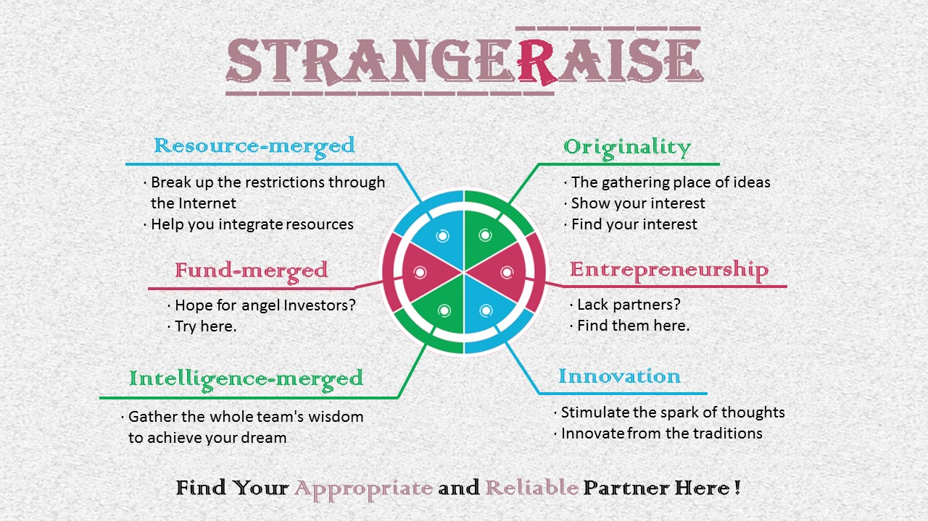

**13 团队分工及项目动态**

**13.1 team members and corresponding responsibility**

|  |  |  |
| --- | --- | --- |
| Name | Role | Responsibility |
| Luo lin | Group leader | In the analysis and design of this program, she discussed and determined the program demands with all members as a leader, having a overall grasp of this program, from participators to system convenience, from thinking about use cases to dividing function modules; she assigned tasks, integrated members’ materials, analyzed the content of program startup, analyzed the business scope and business use cases, analyzed system demands, formulated the definition of specification, analyzed functional demands and non-functional demands, and analyzed the global constraint. |
| Yang xin | Group member | She takes charge of business analysis of the whole system, instructions of business use case, formulation of system global constraint, non-functional demands, data modeling and design of input and output. |
| He minghui | Group member | She takes charge of users’ information management, design of evaluation management, including system user case design, conceptual design, detailed design; she also takes charge of the edition of cover design. |
| Gu yiyao | Group member | She takes charge of user interface design, GUI layout design, GUI navigation design, and prototyping; additionaly, she takes charge of system user case design, conceptual design, and detailed design of course management modules. |
| Wang shuhan | Group member | She takes charge of the module design of project management, file management and user right management, mainly including system user case design, conceptual design, and detailed design. |

**13.2 Project dynamic**

我们的项目名称是Capteam，我们的目标是设计和开发一款贴近大学生实际的团队合作管理平台。在这次项目过程中，我们不断超越自己。小组成员经常聚在一起讨论项目进展情况，并有详细的会议记录和丰硕的会议成果，从而对项目有清晰一致的认知，具有很强的团队凝聚力，下图是我们动态进展一览图。

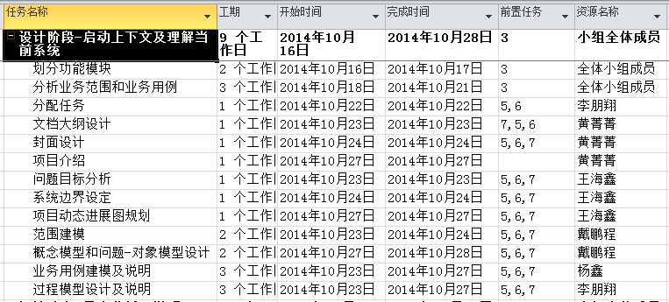

**附件一**

关于大学生寻找创业伙伴的调查

亲爱的同学，您好！

我们正在进行一项关于大学生团队合作情况及团队管理平台使用情况的调查，特开展本次问卷调查，希望能得到您的真实想法与宝贵意见。本问卷实行匿名制，所有数据只用于统计分析， 请您放心填写。题目选项无对错之分，请您按自己的实际情况填写。谢谢您的合作！

1. 请填写您所在的学院、专业及年级：

失

1. 您平均每学期有多少认为非常有创新性的想法？

A.没有 B.1-3 C.4-8 D.8个以上

1. 您的这些创新点子大多是以怎样的形式实现的?

A.只提出点子，没有去实现 B.仅仅凭个人能力去实现

C.寻找合作伙伴 D.寻找专门的商家或者其他

1. 您一般是利用哪些平台去寻找合作伙伴的？

A.即时通讯工具（QQ,微信等） B.论坛 C.线下找人 D.其他方式

1. 寻找合作伙伴，您的平均花费时长是多少？

A.1天以内 B.1-3天 C.3-7天 D.不一定

1. 您是否能够通过自己的努力寻找到合适的合作伙伴？

A.能很好地寻找到 B.一般 C.不容易找到合作人 D.很难找到合适的合作伙伴

1. 请问您每次为实现自己的想法而花费的费用大约有多少？

A.没有 B.50元以内 C.50-300元 D.300元以上

1. 您对于目前的创新点子实现情况是否满意？

A.很满意 B.一般 C.不满意 D.非常不满意

1. 您是否了解或使用过一些寻找合作伙伴平台、软件?

A.使用过 B.了解过但没有使用 C.不知道有这种平台

1. 如果您使用过这些软件，请问您对这些软件有什么建议么？（多选）
2. 没有专门的筹人模块
3. 筹人效果不佳
4. 其他士大 夫

感谢您的配合，谢谢！

**附件二**

关于商家广告发布意愿的调查

您好！

我们正在进行一项关于商家对于广告发布意愿的调查，特开展本次问卷调查，希望能得到您的真实想法与宝贵意见。本问卷实行匿名制，所有数据只用于统计分析， 请您放心填写。题目选项无对错之分，请您按自己的实际情况填写。谢谢您的合作！

1. 请填写您的公司名称：

失

1. 您会不会主动联系平台来发布自己的广告？

A.不会 B.不一定 C.会

1. 如果有其他组织联系你拉赞助，在其产品上打广告，您有意愿么？

A.不愿意 B.愿意 C.不一定，看情况

1. 如果您有意愿，多少钱以内的投入您可以接受？

A.1000以内 B.1000—3000元 C.都可以

1. 您通常会以什么样的方式来发布自己的广告？

A.宣传单、横幅等线下方式 B.微信等社交工具 C.网络平台

1. 一个网站到达多少的使用量时，您愿意在其上投放广告？

A.5000人左右 B.10000人左右 C.十万人

1. 您一般每月在投放广告方面花费多少钱？

A.500元以下 B.2000元左右 C.5000元以上

1. 您对现在的宣传效果是否满意？

A.不满意 B.一般 C.满意

1. 如果您是一家学习类软件或工具公司，您是否希望通过投资，与学习类平台合作，由平台提供接口，使用您的产品？

A.愿意 B.不一定 C.不愿意

感谢您的配合，谢谢！

**参考资料**

中国软件行业基准数据(SSM-BK-201504)

Requirements Analysis and System Design Edit 3

http://zh.wikipedia.org/